

4BCT1 – 2018

**Computer Science & Information Technology**

**Final Year Project**

**Supervisor**

**Dr. Owen Molloy**

[owen.molloy@nuigalway.ie](mailto:owen.molloy@nuigalway.ie)

**Author**

**Gary McMahon**

[g.mcmahon5@nuigalway.ie](mailto:g.mcmahon5@nuigalway.ie)

**14534653**

# Declaration of Authorship

I, Gary McMahon, declare that this thesis and the work presented in it are my own and has been generated by me as the result of my own original research. I confirm that:

* This work was done wholly or mainly while in candidature for a research degree at this University;
* Where any part of this thesis has previously been submitted for a degree or any other qualification at this University or any other institution, this has been clearly stated.
* Where I have consulted the published work of others, this is always clearly attributed.
* Where I have quoted from the work of others, the source is always given. With the exception of such quotations, this thesis is entirely my own work.
* I have acknowledged all main sources of help.
* Where the thesis is based on work done by myself jointly with others, I have made clear exactly what was done by others and what I have contributed myself.

Signed:

Date:

# Acknowledgments

I would like to thank my project supervisor Dr. Owen Molloy of the Department of Information Technology. Owen was always available on short notice and was always willing to share his opinion and give advice on the direction the project should take but at the same time allow the project to be my own work.

I would also like to thank Caroline Brennan for her continued guidance and facilitating any requests I had in regards to extra back-end modifications and data required for the project.

Lastly, I would like to thank Conor McCrossan for his help and patience. Conor was always available on short notice and was a huge help when I needed advice and direction when I encountered early problems with the project.

# Abstract

# List of Figures

Figure 1.1 Gantt Chart showing project Timeline 2

Figure 2.1: Simplified story demonstrating the placement of each node type and the use of Actors and Knowledge. 4

Figure 2.2: Displays the expected flow of framework along with basic definitions for each type. 5

Figure 2.3: System Architecture 6

Figure 3.1: Using Chrome console tab for debugging. 9

Figure 3.2: Use Chrome Dev Tools sources tab for debugging. 9

Figure 4.1: Initial paper prototype created in the design phase. 12

Figure 4.2: Use Case Diagram for ResponSEAble 13

Figure 4.3:Activity diagram for load story 14

Figure 4.4: Activity diagram for Click Toggle Knowledge/Actor Button 15

Figure 4.5: Activity diagram for when a user clicks a node 16

Figure 4.6: Activity diagram for get Causal Evidence 17

Figure 4.7: Design we produced on our application 18

Figure 5.1: MainViewer.html rendered in the Browser 19

Figure 5.2: Toggle Knowledge Button and onClick event 19

Figure 5.3: JQuery that detects if a user clicks on the blue buttons in the graph data viewer 20

Figure 5.4: Example of node JSON data 20

Figure 5.5: Example of Edge JSON data 20

Figure 5.6: Code that determines how much of each node type is present 21

Figure 5.7: Assign each its initial position 21

Figure 5.8: Draw DAPSIWR node 22

Figure 5.9: Node-specific images are loaded based on the category types 23

Figure 5.10: Example of JSON data for edge type ‘S’ 24

Figure 5.11: Code to draw canvas Edge 24

Figure 5.12: Get the source and target canvasId 24

Figure 5.13: getCanvasIdByDatabaseId () function 25

Figure 5.14: Easily access databaseId and id property in a graph element. 25

Figure 5.15: Example of an edge of linkType C1 & C2 26

Figure 5.16: Example of a LinkEvidence node 26

Figure 5.17: Finding the target and source canvasId for a causal link 27

Figure 5.18: If the node is of type ‘Response’ we add it to an array containing all response nodes. 27

Figure 5.19: Test to ensure no backward edges are drawn. 27

Figure 5.20: Call setup function on newEdge and pass the databaseId to it. 28

Figure 5.21: Add the databaseId property to the new node when setup is called. 28

Figure 5.22: Example of a causal link with relNode appended 28

Figure 5.23: Typical JSON data format for a Knowledge node. 29

Figure 5.24: Code to determine how many knowledge nodes are connected to each node. 30

Figure 5.25: Draw all knowledge nodes in the background when the initial page has loaded 31

Figure 5.26: Loop through the knowledge node data and sort the data depending on its KGroup 31

Figure 5.27: Find the node position and radius of the source node 32

Figure 5.28: Define variables to find orbit positions and find the number of unique knowledge types 32

Figure 5.29: Function call to get coordinates for each knowledge node 32

Figure 5.30: Knowledge is place at equidistant locations around its parent 33

Figure 5.31: Method to find knowledge node position based on parent size and position 33

Figure 5.32: Code that calls the draw knowledge node function 34

Figure 5.33: Draw Knowledge node 35

Figure 5.34: Example of supportingKnowledge appended to knowledge node. 35

Figure 5.35: Position the text (number) to the right of the kNode. 36

Figure 5.36: Position the text(number) to the left of the kNode. 36

Figure 5.37: Example of how knowledge is drawn around its parent node. 36

Figure 5.38: Determining the combined knowledge score for each Knowledge type 38

Figure 5.39: Draw a pie chart to represent knowledge node 38

Figure 5.40: Example of how pie chart looked for displaying knowledge data 39

Figure 5.41: JSON data for Actor node 40

Figure 5.42: Add all actor nodes present in JSON data to a single array. 40

Figure 5.43: Code that determines if a node has an Actor node connected to it. 40

Figure 5.44: Example of Actor node connected to parent 41

Figure 5.45: Detects when a user clicks on a node(cell) on the paper 42

Figure 5.46: Data contained in cellView 42

Figure 5.47: Loop through all cells in the graph 42

Figure 5.48: Compare cell and cellView canvasId to find the connected edges and nodes 43

Figure 5.49: Loop over each array and draw the connected nodes and edges 43

Figure 5.50: Before click with no Knowledge or Actors displayed 44

Figure 5.51: After click event with both Actor and Knowledge nodes visible. 44

Figure 5.52: Display/Hide all Knowledge nodes in the graph on button toggle 45

Figure 5.53: Graph before and after all Knowledge was activated. 45

Figure 5.54: Toggle display status for Actor nodes and edge. 46

Figure 5.55: Graph before and after Actor nodes and links were activated 46

Figure 5.56: Bootstrap buttons that contain parent ‘list-group’ 47

Figure 5.57: Use JQuery to hide buttons and empty divs 47

Figure 5.58: Supporting knowledge is maintained in each knowledge node and easy to access 48

Figure 5.59: Find all connected Knowledge and Actor nodes and add them to separate arrays 48

Figure 5.60: Access nodeData and nodeType 48

Figure 5.61: Check to ensure array isn’t empty and call appropriate functions 49

Figure 5.62: Use JQuery to change display status and dynamically append JSON data 50

Figure 5.63: Example of how we access key-value pairs. 50

Figure 5.64: Node data displayed in the drop-down menu. 50

Figure 5.65: Format of the array as it arrives in DisplayKnowledgeData 51

Figure 5.66: Informs the user of the knowledge category and the number of Articles present 51

Figure 5.67: Dynamically creating collapsible list groups that can hold Knowledge Data 51

Figure 5.68: Inform user that they are viewing the first article 52

Figure 5.69: Iterate over the inner array and dynamically append JSON data 52

Figure 5.70: Format of data received by DisplayActorData function 53

Figure 5.71: Append Actor data to list-group 53

Figure 5.72: Node Data viewer after all data has been appended 53

Figure 5.73: Detect Button click 54

Figure 5.74: Detect user clicks on individual list-groups 54

Figure 5.75: User has selected start and end node to retrieve causal evidence 55

Figure 5.76: Format of JSON data returned for Causal Evidence 56

Figure 5.77: Extract all knowledge returned in JSON data 57

Figure 5.78: Add knowledge type to a single array and send the array to displayCausalKnowledge 57

Figure 5.79: Set display status of viewCausalSummaryButton to visible 58

Figure 5.80: Causal Evidence is displayed in the viewer and separated by category 58

Figure 5.81: Bootstrap button that user clicks to view causal summary 59

Figure 5.82: Render modal window that will display the graph 59

Figure 5.83: JQuery detects button click and appends bar Chart to the modal canvas 59

Figure 5.84: Define labels (x-axis values) 60

Figure 5.85: Set the height of each bar using the amount of each knowledge category present 60

Figure 5.86: Causal Data Summary chart 60

Figure 5.87: Button to print chart contents on click 61

Figure 5.88: Hide all content except what we wish to print 61

Figure 5.89: Print Preview 61

Table of Contents

Declaration of Authorship i

Acknowledgments ii

Abstract iii

List of Figures iv

1 Introduction 1

1.1 What is ResponSEAble 1

1.2 Project Objectives and Goals 1

1.3 Project Timeline 2

2 Technical Review 3

2.1 The DAPSIWR Framework 3

2.2 The System Architecture 5

2.2.1 Server-Side 5

2.2.2 Client-Side 6

2.3 Current UI Functionality 7

2.4 Problems 7

3 Technologies Used 8

3.1 Tools 8

3.1.1 NetBeans Ide 8

3.1.2 GitHub 8

3.1.3 Chrome and Dev Tools 8

3.2 Languages 9

3.2.1 HTML 9

3.2.2 JavaScript 9

3.2.3 CSS 9

3.3 Libraries/Frameworks 9

3.3.1 JointJS 9

3.3.2 SVG 10

3.3.3 Chart.js 10

3.3.4 JQuery 10

3.3.5 Twitter Bootstrap 10

3.3.6 Orient DB 10

4 Analysis and Design 11

4.1 Paper Prototype for Application 11

4.2 Knowledge 12

4.3 Use Cases 13

4.4 Activity Diagrams 13

4.4.1 Load Story 13

4.4.2 Click Toggle Knowledge/Actor Button 14

4.4.3 User Clicks a Node 15

4.4.4 User wants to retrieve Causal evidence between two nodes 16

4.5 1. Story Layout - Develop an intelligent user interface that the user can interact with. 17

4.6 2,3 &4 Allow user to use navbar buttons toggle the status of Knowledge and Actor nodes. 18

4.7 5. Design a method of allowing the user to query specific sections of stories that allows supporting evidence to be returned. The user should be allowed to interactively select the start and end points. 18

5 Implementation 19

5.1 Project Structure Overview 19

5.2 MainViewer.html 19

5.3 mainViewer.js 20

5.3.1 Load JSON Data 20

5.3.2 Display nodes 21

5.3.3 Draw Node Edges 24

5.3.4 Draw Knowledge Nodes & Edges 29

5.3.5 Draw Knowledge Edge 37

5.3.6 Draw Knowledge Nodes (alternate method) 38

5.3.7 Draw Chart.js pie chart to represent Knowledge data 38

5.4 Draw Actor Nodes 40

5.4.1 Create an array that contains all actor nodes in the JSON data 40

5.4.2 Determine if a node has a connected Actor node 40

5.4.3 Draw Actor Edge 41

5.4.4 Show connected Knowledge & Actor nodes when the user clicks a node 42

5.4.5 Determine what edges and nodes are connected to a single node 42

5.4.6 Show Knowledge and Actor Nodes 43

5.4.7 Draw all Knowledge Nodes on Button Toggle 45

5.4.8 Draw all Actor Nodes and Edges on Button Toggle 46

5.4.9 Display Data Relevant to each node 47

5.5 Detect User click on button and lists 54

5.5.2 Display Causal Summary 55

5.5.3 Draw Summary Graph for Causal Data 59

5.5.4 Allow the user to print the Summary Chart 61

6 Conclusion 62

7 Future Work 63

8 References 64

*Chapter 1*

# Introduction

This chapter provides a brief overview of the project and its goals, along with an introduction to the project timeline.

## What is ResponSEAble

“ResponSEAble is an interactive website that supports the development of cost-effective ocean literacy in Europe. It is an ambitious, 15-partner project and is funded by Horizon 2020. ResponSEAble is mapping European marine research and knowledge to further our understanding of complex human-ocean relationships and the economic benefits that we derive from our seas and the ecosystems they support” [1].

ResponSEAble is an iterative website with that was created with the goal of conveying complex marine research and knowledge to non-expert audiences. To achieve this goal the causal framework Driver-Pressure-State-Impact-Response(DPSIR) was examined and a new variation was created which allows specialists to map their knowledge on various marine conservation themes.

## Project Objectives and Goals

Based on the Research undertaken in Chapter 2 I determined my main objective is to develop an interactive, intelligent user interface for exploring the knowledge in the graph database, both visually and using queries.

To achieve this objective, the following main goals must be met:

* Develop an intelligent user interface that the user can interact with.
* Design a method of allowing the user to query specific sections of stories that allows supporting evidence to be returned. The user should be allowed to interactively select the start and end points.
* Design and implement a method of visually displaying the evidence that is present in a specific link or the evidence returned from a query.
* Develop a method that will visually inform the user that a specific link or vertex has supporting evidence.
* Design and implement a method of displaying node-specific data.
* Develop a method for displaying Actor specific data.
* Develop a method of displaying to the user if a specific link or vertex has Actors connected to it.

The purpose of this project to create a develop an interactive, intelligent user interface for exploring the knowledge in the graph database, both visually and using queries. The UI should have a logical flow to its structure that makes it easy to read. Users will be able to visually explore and examine specific stories. The interface should inform the user of how much evidence is supporting each node and the causal links between nodes. This allows users to learn from the stories. Users can select specific start and end nodes on the graph and retrieve the causal evidence that supports them being linked.

## Project Timeline

This project was completed between October 2017 and April 2018. The project was divided into several short phases with the Agile methodology in mind. The goal was to create short sprints that allowed me to break the large main goals down into smaller subtasks that could be completed in the space of a few days rather than weeks.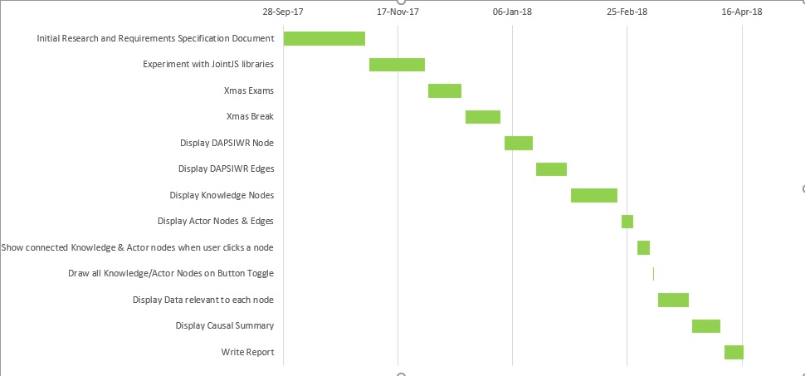

Figure 1.1 Gantt Chart showing project Timeline

*Chapter 2*

# Technical Review

This chapter explores the techniques and methodologies that are currently in use in the ResponSEAble codebase, these will include how stories are stored in the OrientDB database along with the system architecture. We will also be looking at the DAPSIWR framework that is used in the project and what each it represents. Using this knowledge, we will then review the problems with the current application which will help determine the main goals for my application.

## The DAPSIWR Framework

https://en.wikipedia.org/wiki/DPSIR

“DPSIR is a causal framework for describing the interactions between society and the environment and vice versa”. Components of the model include (Drivers-Pressures-States-Impacts-Responses).

In this project the DPSR framework was adapted and modified to create the DAPSIWR framework (Drivers-Activities-Pressures-States-Impacts-Welfare-Responses). New categories to represent Actors and Knowledge were also created. This was done to help us better model the human-ocean relationship.

The goal is to allow marine experts to use this new framework to build causal maps that represent specific problems. The expert will select the most relevant types from the DAPSIWR taxonomy and place them on a canvas, add relevant details, and then link types via a causal link. Experts can then link Actors or Knowledge to the causal links or the nodes themselves. Actors and Knowledge serve to strengthen the reasoning behind a causal link or nodes presence on a graph.

In Figure 2.1, a growth in tourism (a Driver) drives beach-based tourism (an Activity), causing coastal debris (a Pressure), and so on. The ‘general public’ are involved in the activity (an Actor), and a scientific article, a flyer, and a film are attached (Evidence).

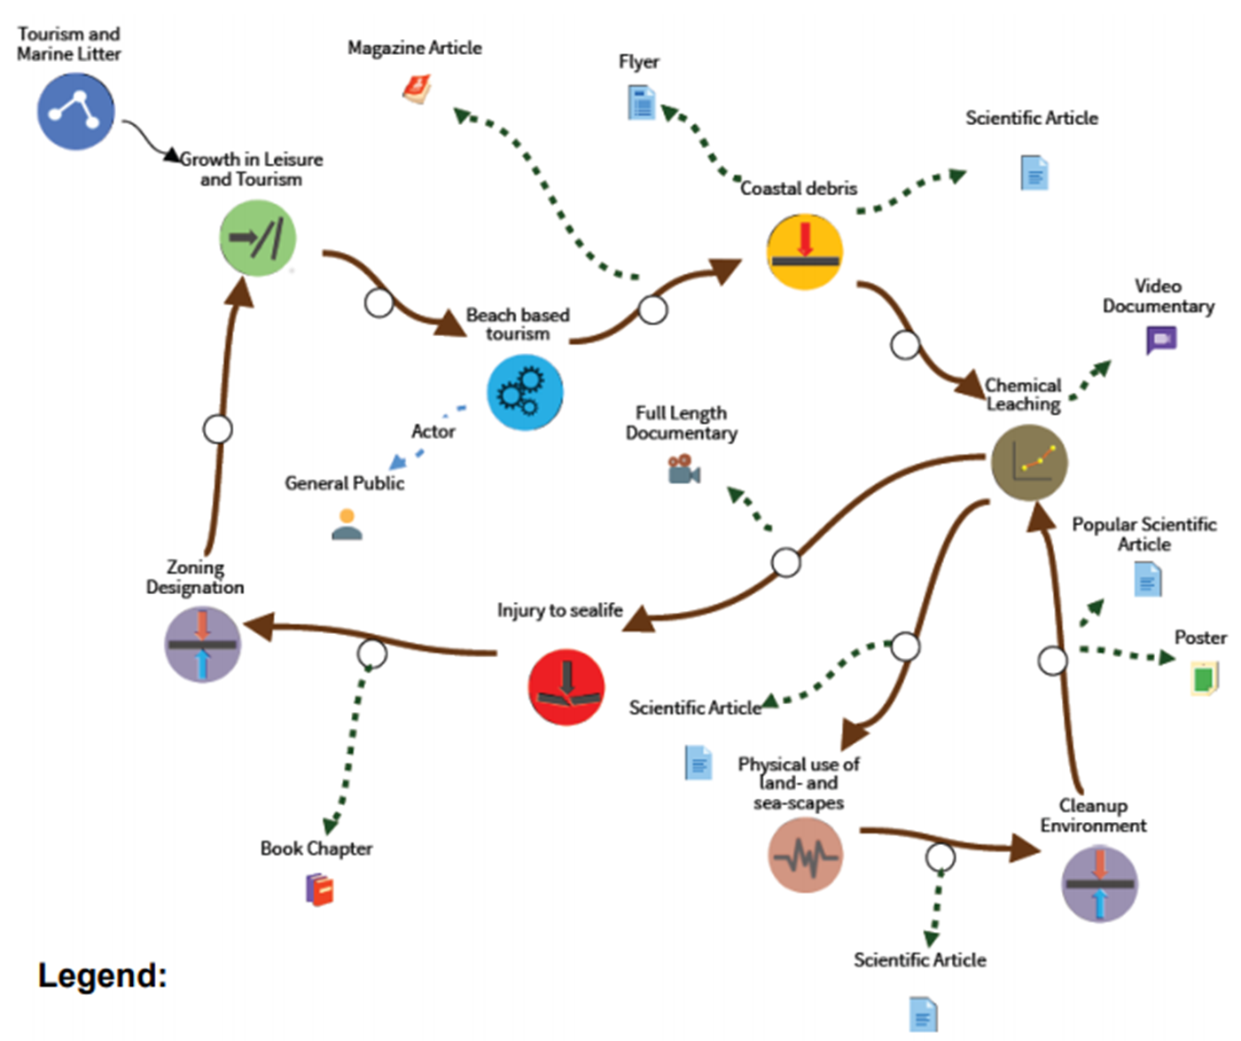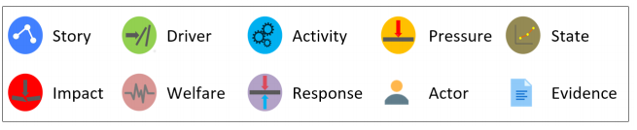

Figure 2.1: Simplified story demonstrating the placement of each node type and the use of Actors and Knowledge.

Figure 2.2 provides a description of the basic definition different categories for the DAPSIWR framework and how we expect them to interact. i.e. the flow of the graph. In Figure 2.1 and Figure 2.2 we see an extra type that is not included in the new DAPSIWR framework. This is the Story node. This node is used to provide a summary of the graph and what it entails. It is also used when we want to retrieve a story from the database. As there will only every be one story node per graph we can use this as the unique starting point at which to begin our traversals when retrieving a story.

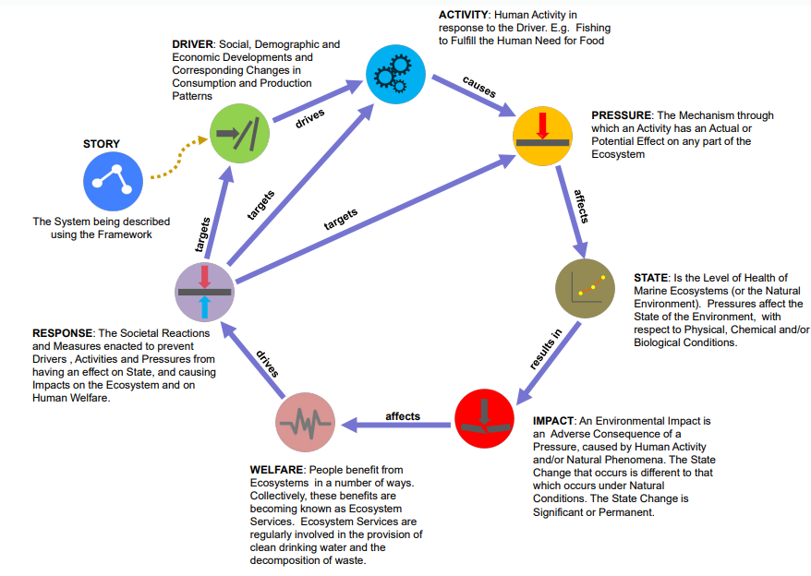

Figure 2.2: Displays the expected flow of framework along with basic definitions for each type.

## The System Architecture

### Server-Side

A graph database (OrientDB) is used to store the modelling framework along with graphs corresponding to individual Stories. OrientDB serves two purposes;

1. It stores the graphs corresponding to each individual Story. When a user selects a story to view the id of the story node is passed to the function responsible for loading the Story from the database.

2. It is also used to store the modelling framework(Schema). Although we have created a DAPSIWR framework to categorise our data the reality is that behind each category is many layers of sub-categories.

Consider Drivers for example are composed of 2 subclasses which consist of their own subclasses which are could be even further broken down if necessary. E.g.

Drivers:

1. Indirect Drivers:

* Demographic Drivers:
* Population Variability
* Age Distribution

1. Direct Drivers:

* Climate Change Related Drivers:
* Greenhouse Gas Emissions
* Sea Level Rise

Our OrientDB stores these classifications and maps the subclasses to the correct parent class.

RESTful web services are used when the client and server wish to communicate due to some user action of the client side. Th

The back-end is build using Java Enterprise (JEE).

### Client-Side

The client-side consists of a browser-based interface that is built suing a combination technologies and frameworks that include Rappid and Bootstrap. We will talk more about these in Chapter 3.

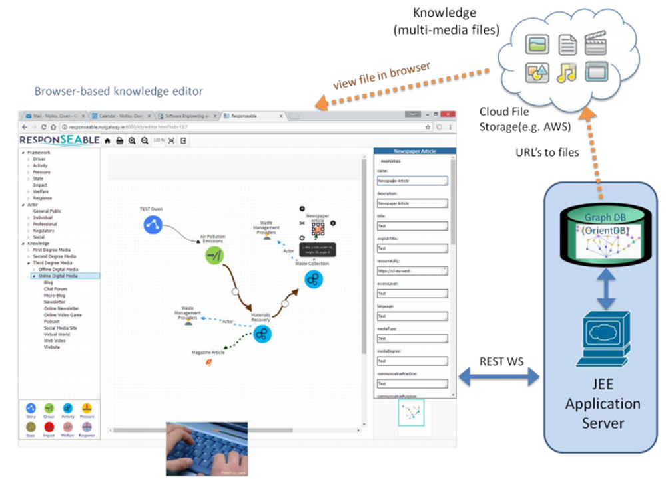

Figure 2.3: System Architecture

## Current UI Functionality

As it stands we currently provide the user with an interface that allows them to view the causal map of Stories and saturate the maps with details such as causes and effect along with knowledge and actors to back up these causes and effects. Due to the complexity of the systems involved the design of the output is challenging. Currently the layout of the graphs depends entirely on the how the expert created it, which puts a lot of pressure on the expert to develop a clear and concise graph. See Figure 2.1 for an example of the current UI.

## Problems

One of the current problems with the current system is that of how to represent Complex Knowledge. How we present problems of a causal nature within complex systems in a way that is both communicative and easy to understand is difficult to achieve. The problem is that as the expert adds more detail to the Story’s they quickly become clustered which can result in often unreadable graphs if presented in full. Similarly, the current UI doesn’t have the capability to allow a user to query the Knowledge that supports the causal link between two nodes.

It is from this examination of the current problems within the website that I was able to draw up a list of the main objectives for this project as discussed in Chapter 1.

*Chapter 3*

# Technologies Used

This chapter provides information on the various technologies used in the project, what they were used for and why I choose to use them. The technologies used can be broken down into 3 categories.

* Tools - provides details on the tools used for code development and version control.
* Languages - Provides details on the languages used to build the UI
* Frameworks/Libraries – Provides details on the Frameworks/Libraries used.

## Tools

The decision on what tools to use as part of the project was extremely important. It was critical to ensure that the correct tools were used to increase the speed and ease of development but at the same time preserve the developer’s knowledge of the inner workings of the application. This section gives a better understanding of the tools used in the development process.

### NetBeans Ide

Used for the coding/developing the UI. Used NetBeans in conjunction with GlassFish server to run the application. This editor supports all the necessary technologies and languages required for the project. It also allows for extensions to the editor using plugins. NetBeans allows for easy and readable presentation of code and the decision to use it over other IDE’s was down to personal preference. [2]

### GitHub

Used for version control and source management. Most popular and accessible version control application available. [3]

### Chrome and Dev Tools

One of the most important tools used in the project development was Chrome and its Dev Tools. Their performance, feature set, and usability are unapparelled. It’s the first point of call when an error occurs and it makes the sometimes-difficult process of debugging JavaScript that much easier. The time and effort saved by using the console tab to view simple things like the current structure of JSON data were invaluable.

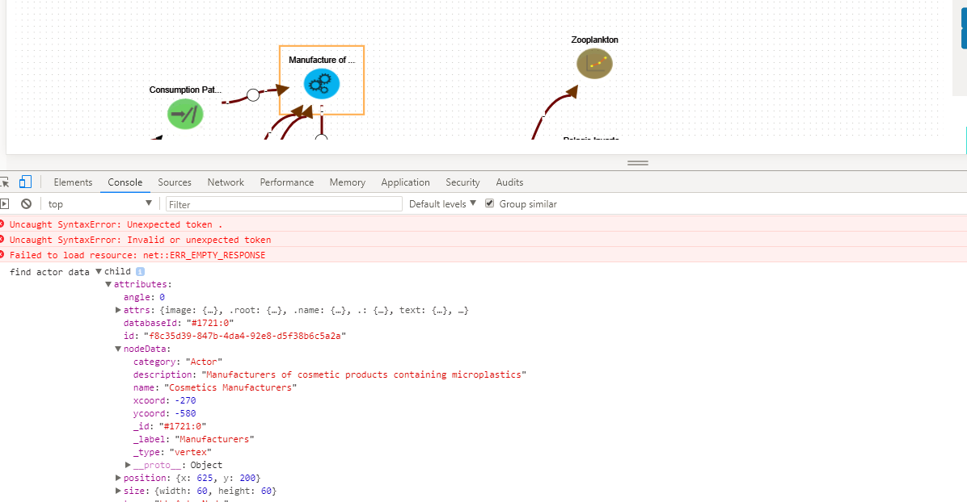

Figure 3.1: Using Chrome console tab for debugging.

Another key feature of Chrome and its developer Tools was the ability to use the source tab to debug code in real time as you performed click events on the application.

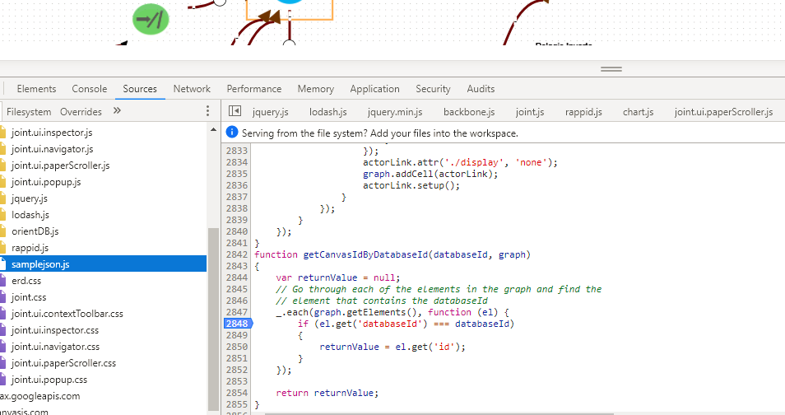

Figure 3.2: Use Chrome Dev Tools sources tab for debugging.

## Languages

### HTML

HTML or Hypertext Markup Language is used to tell the browser how to display a web pages’ data to a user. HTML is supported across all major browsers which makes it the ideal language to display our content with. HTML was created to describe the contents of a page. [4]

### JavaScript

Due to the non-static data that will be displayed on our web pages, we need to use JavaScript in conjunction with HTML pages which allows for the creation of a dynamic and interactive application. JavaScript is stored in separate JavaScript files to make code readability easier. JavaScript is supported across all modern browsers. [5]

### CSS

Cascading Style Sheets (CSS) describes how HTML elements are to be displayed on screen, paper, or other media. CSS can be used to control the layout of multiple web pages all at once. CSS was introduced when tags such as <font> and color attributes were added to HTML to create a single source of styling instead of having to add styling to every single page. [6]

## Libraries/Frameworks

### JointJS

JointJS is JavaScript library that can be used to dynamically create static or fully interactive graphs and diagrams from JSON data retrieved using Ajax. JointJS was the main language used in the creation of the user interface. JointJS allowed for the creation of custom shapes via SVG and the rendering of potentially hundreds of elements and links with instant interaction. Zooming, animations and touch support are just some of the features of JointJS. [7]

JointJS was used to draw all nodes and edges on the graph.

### SVG

Scalable Vector Graphics (SVG) allows graphics objects, images and text to be rendered. SVG is XML based which means that every element is available within the SVG DOM and can attach JavaScript handlers to each element. In SVG, each drawn shape is remembered as an object and thus if the attributes of an object are changed, the browser can automatically re-render the shape. SVG makes use of CSS for styling and JavaScript for scripting. The SVG library is included as standard in the JointJS Library. [8]

### Chart.js

Chart.js is a JavaScript open-source library that helps you easily visualize data using JavaScript. It supports 8 different types of chart and they’re all responsive. Chart.js is used to summarise the causal data between two nodes in the form of a bar chart. Chart.js was used over JointJS as it offered greater flexibility and faster implementation. [9]

Chart.js was used on this site to create a bar chart that displays a summary of the causal evidence between two nodes.

### JQuery

jQuery is a lightweight, "write less, do more", JavaScript library. JQuery is a free open-source JavaScript library whose purpose is to simplify the use of JavaScript on your website. It provides methods to perform tasks that would otherwise require many lines of code helping to simplify the development process. [10]

In this application, JQuery was used to detect user interaction with HTML button elements and dynamically append data to them along with toggling their display status.

### Twitter Bootstrap

Bootstrap is the most popular HTML, CSS, and JavaScript framework for developing responsive, mobile-first websites. Bootstrap can be used to automatically divide the layout of a web page to best fit the device they are being viewed on. Bootstrap offers plenty of support and has many templates that allow for quick implementation. [11]

In this project, bootstrap is used to control the layout of the UI and to also provide other features such as toggle buttons and modal popups.

### Orient DB

Orient DB is the database that is used to store all the graphs. It’s an open source NoSQL Database and is written in Java. It supports different models but we are using it primarily for Graphs. My work won’t involve much manipulation of the database but it is still important to know the basics. [12]

*Chapter 4*

# Analysis and Design

This chapter looks at the design decisions that were undertaken to address each of the key objectives outlined in Chapter 1.

## Paper Prototype for Application

The initial prototype for the user interface for displaying a story in Figure 4.1 is as follows. This was created in the Project Definition Document and outlines how I intend to display the Story along with the data associated with each node and query.

**1**. Each Vertex type should be displayed in its own column. The first column should be reserved for Stories only, the second column for Drivers, the third column for Activates and so on.

**2**. The user should have access to buttons on navbar that allows them to toggle the status of Knowledge and Actor nodes. They should also be able to create a query to return causal evidence between two points.

**3.** As you can clearly see the link between the driver and the State is much larger than all the other links. This is a potential method for visually displaying to the user that there is a lot of evidence to back up the link between these two vertices.

**4.** The node has some indicator around it that like point 3 this is can be a potential method for visually communicating to the user that this vertex has supporting evidence.

**5.** This is where the user can input a custom query. They can use this query to request all the evidence between certain points on the graph. The user can either type in the points they want the query to start and end with or they can click the start and finish vertices manually on the node. An example of a query would be “return all evidence linking Driver (D1) to State (S1)”.

**6.** From the user query generated in part 6, the evidence would be displayed here and would be broken down into the different types. E.g. Video evidence, Journals, Research papers, Verified Facts, News Paper articles. Similarly, if a user clicks on a specific node or link then the evidence supporting the link will appear here.

**7**. The user can then click on each different type of evidence. Say the user clicks Journals. The dropdown should be populated with all Journal evidence.

**8.** This is an already existing feature which I will incorporate and extend in my final solution. It will display all data that is relevant to a node which the user selects. This data could be the actual node data, knowledge data that is linked to that node or data relevant to actors that are also connected.



Figure 4.1: Initial paper prototype created in the design phase.

## Knowledge

As discussed earlier Knowledge exists in this application with the purpose of supporting the causal link between two nodes or to support the presence of a node on the graph. The more Knowledeg a node or causal link has supporting it the better the quality of the graph will be.

During the design phase, it was decided that all types of Knowledge needed a new taxonomy to help better categorise Knowledge. It was decided that all Knowledge would be a divided into 8 parent categories or kGroups. Like the DAPSIWR nodes each of these kGroups would have several sub-categories which themselves could consist of even further sub-categories.

The new 8 kGroups are:

1. Visual and Performance Arts
2. Education and Public Events
3. Non Academic Press
4. Scientific Print Media
5. Broadcast Media
6. Film
7. Other
8. Online Digital Media

When we display Knowledge relevant to each node we will separate all data into these 8 categories.

## Use Cases

Figure shows a visualization of the different User interactions that will be available on the application.

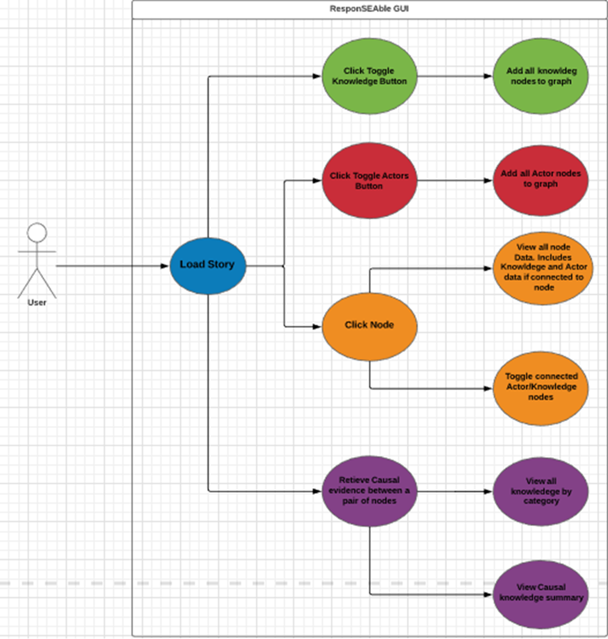

Figure 4.2: Use Case Diagram for ResponSEAble

## Activity Diagrams

### Load Story

When the user initially loads a story a query is sent to OrientDB to retrieve the story data. Once the story has been returned, the JSON data is cycled through and the size of the paper is determined based on the highest number of node category present. Once we have determined the size of the canvas and the starting point for each node category we again cycle through the JSON data and draw all DAPSIWR nodes on the canvas. We do not draw any actor or knowledge nodes at this point. Once we have all the nodes drawn we then cycle through all the edge JSON data and draw all edges on the graph. At this point the page has finished loading and the user can view the graph.

Once the page load completes we run the process necessary to draw all knowledge and actor nodes along with the navigator in the background. The user doesn’t notice this happening as initially all actor and knowledge nodes aren’t displayed. We do this as these are very computationally expensive processes and delay initial page load by 4-5 seconds.

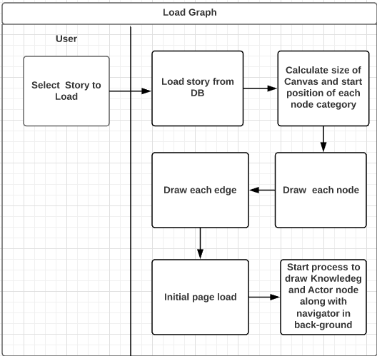

Figure 4.3:Activity diagram for load story

### Click Toggle Knowledge/Actor Button

When a user initially clicks the toggle Knowledge or Toggle Actor button we need to find all Knowledge or actor nodes currently drawn on the graph and display them. If the Knowledge or Actor node is already being displayed, then we leave it displayed.

When the user decides, they want to turn off all knowledge or Actor Data on the graph we again must find all Knowledge or Actor nodes and hide them.

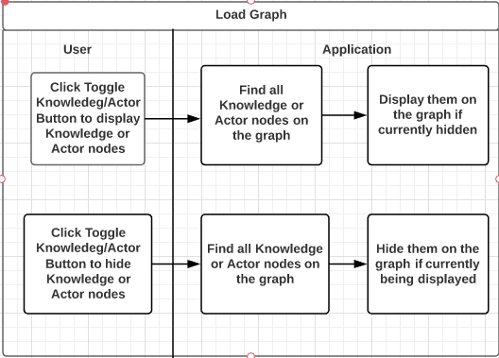

Figure 4.4: Activity diagram for Click Toggle Knowledge/Actor Button

### User Clicks a Node

When a user clicks on a specific node we want two actions to be performed.

1. Toggle the display status of all connected nodes to that node. This approach is like that undertaken for when a user clicks the toggle Knowledge or Toggle Actor button. The only difference is we only want to display the Knowledge and Actor nodes connected to one node.
2. Find all data related to the selected node and all data related to the connected Knowledge and Actor nodes and display it. To do this we retrieve all data for the node itself and that of any connected Knowledge and Actor nodes. If Knowledge data is present we separate it up into its 8 different categories before displaying it by category. We then append this data to list drop-downs on the right-hand side viewer which the user can view.

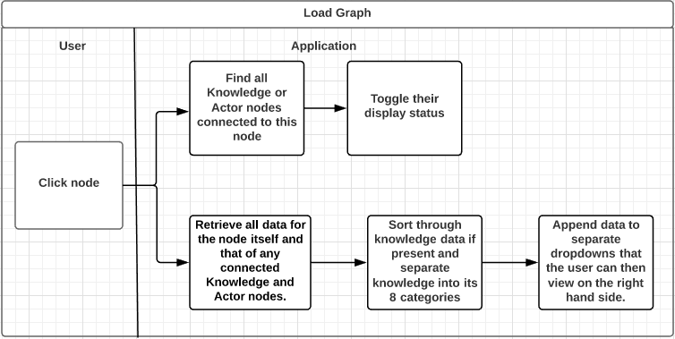

Figure 4.5: Activity diagram for when a user clicks a node

### User wants to retrieve Causal evidence between two nodes

When a user clicks a toggle button on the navbar they will be given the option to select a start and end node with the goal of retrieving all causal evidence for the path between these two nodes. When the user submits this query, we want two outcomes.

1. We want to user to be presented with data like what happens with knowledge data when a user clicks a node. We do this by retrieving all causal data from the database for this path. We then separate the knowledge into its 8 different categories. We then append the data to a dropdown list on the left-hand side where the user can view and examine the data.
2. We want the user to have an option to view the causal data summary. When the data is returned from the query it is sorted into its 8 categories like above. We then use the number of each article category present as the metric for which to display this data on a bar chart built using chart.js. This will be viewable to the user on a click of a button.

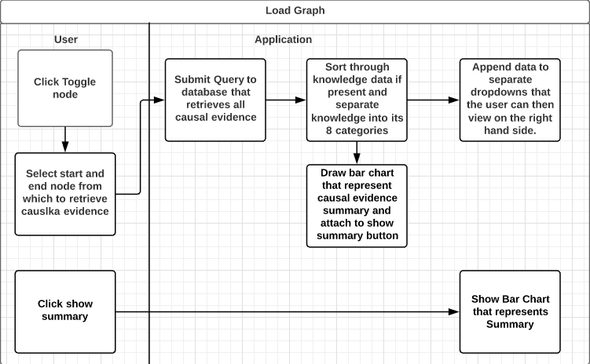

Figure 4.6: Activity diagram for get Causal Evidence

## 1. Story Layout - Develop an intelligent user interface that the user can interact with.

The first problem to be addressed was to create a method of displaying all nodes in a pre-determined order. In the current method of displaying stories, the layout of the story depends entirely on how it was created and thus if the graph was created with little or no order it makes it very difficult to read. In the Project Definition Document, a Paper Prototype was created for the user interface for displaying a story. The key goal was to assign each Node type its own column. This was to help preserve the flow of the graph and make it more readable. It also takes the pressure off the creator of the graph, they don’t need to worry about creating the graph in a neat and readable format.

When designing the order in which we expect the nodes to follow we operate under the assumption that graphs, for the most part, will follow the DAPSIWR (Driver 🡪 Activity 🡪 Pressure 🡪 State 🡪 Impact 🡪 Welfare 🡪 Response) format. This means that all links will follow a logical flow from one vertex type to the next. We also made the decision to only populate the initial page with DAPSIWR nodes to make it more readable. The user will be allowed to toggle the status of these nodes.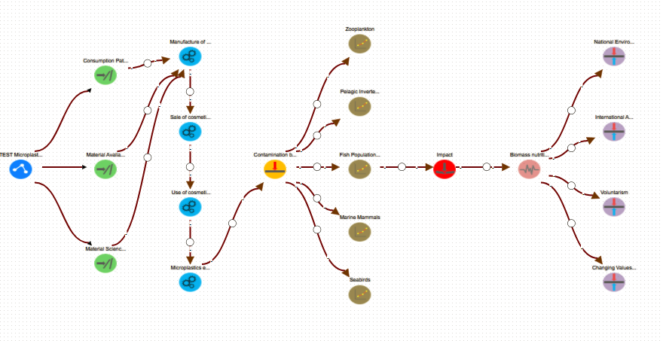

Figure 4.7: Design we produced on our application

## 2,3 &4 Allow user to use navbar buttons toggle the status of Knowledge and Actor nodes.

We wanted the user to be able to toggle the display status of either all Actor or Knowledge nodes at a click of a button. For this purpose, we decided that bootstrap buttons on the navbar would be sufficient. These buttons also served as a useful in helping give the user visual aid in informing the user of how much knowledge supports each node/Causal link as mentioned in point 3 & 4. Once turned on it is easy to tell which links or nodes has the most evidence supporting it.

## 5. Design a method of allowing the user to query specific sections of stories that allows supporting evidence to be returned. The user should be allowed to interactively select the start and end points.

We wanted the user to be able to any two nodes on the graph and query the evidence that supports the causal relationship between these two nodes. We decided that when a user selects both the start and ends nodes on the webpage an ajax call containing the databaseId’s of the start and end point would be sent to the back-end which would return all causal evidence between these two points. Meanwhile on the front end the user would be visually informed of the start and end points they had selected. Similarly, the path for which the knowledge was being retrieved should be highlighted to visually inform the user of what path this evidence supports. When the evidence has been retrieved the it should be presented to the user on the right hand side of the screen. The user should alos have an option

*Chapter 5*

# Implementation

This chapter provides a detailed description of how all the systems features are implemented in code.

## Project Structure Overview

This project consists entirely of a client side application in the form of a user interface. The interface consists of one HTML web page which uses Bootstrap to control the styling and layout. This page uses JointJS to draw all nodes and edges, Chart.js to create summary charts and JavaScript along with JQuery is used to enable interactivity

## MainViewer.html

This HTML file is used to display the graph that the user has selected and was drawn by mainViewer.js. Its uses Bootstraps Grid System to divide the page into sections. On the left-hand side taking up 9 columns is the graph itself and on the right-hand side taking up 3 columns is the graph data viewer. This is where data is appended when the user selects a node or generates a Query.

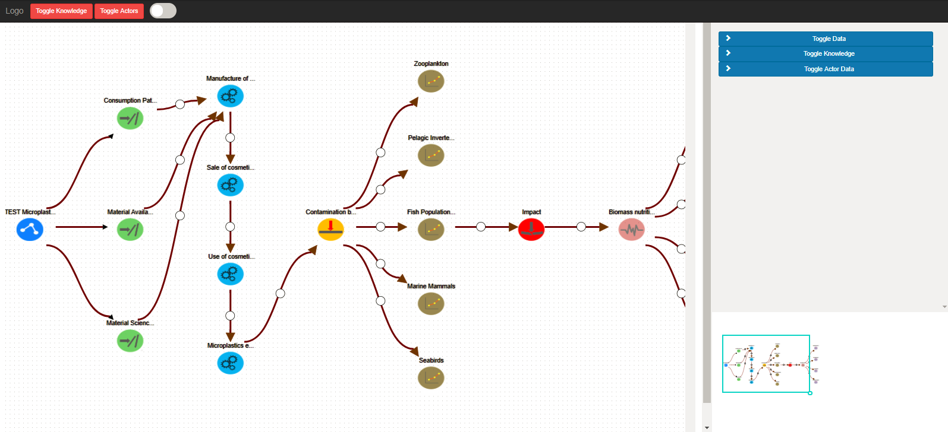

Figure 5.1: MainViewer.html rendered in the Browser

The page has several buttons. The Toggle Knowledge and Toggle Actors buttons at the top of the page on the navbar are rendered using bootstrap. When the user clicks, these buttons an onClick event in mainViewer.js is triggered and control is passed to the appropriate function in mainViewer.js to toggle all Knowledge or Actor nodes. The navbar also contains a toggle switch that when selected allows the user to select a start and end node which will submit a query to the OrientDB that returns all causal evidence on the selected path.

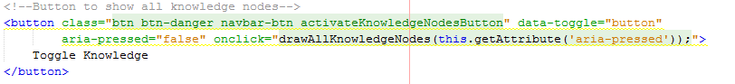

Figure 5.2: Toggle Knowledge Button and onClick event

We can see on the right-hand side that there is 3 blue buttons. These Buttons are appended to the right-hand side viewer when the user clicks on a node. JQuery is used to detect is a user selects one of these buttons which will then expand and display the data contained in them.

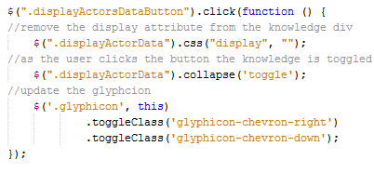

Figure 5.3: JQuery that detects if a user clicks on the blue buttons in the graph data viewer

## mainViewer.js

The mainViewer.js file is responsible for loading all JSON data from the OrientDB and displaying the Story. This file also takes care of user inputs on the graph along with generating the expected responses to these events, such as displaying data.

### Load JSON Data

When the user selects a story to view a call is sent to the OrientDB and retrieves the relevant JSON data. The data returned consists of two separate arrays of vertices and edges.

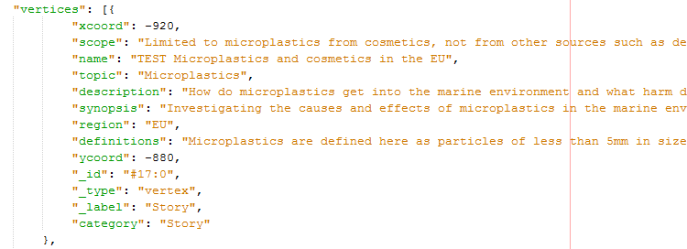

Figure 5.4: Example of node JSON data

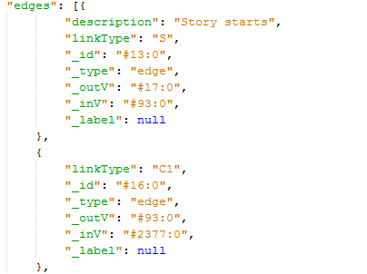

Figure 5.5: Example of Edge JSON data

### Display nodes

The following is the method to draw the DAPSIWR node types. As stated earlier the Actor and Knowledge nodes are drawn after the initial page load as they require a more computationally expensive process to draw.

#### Determine X and Y co-ordinates

When the story is initially loaded from the DB using a pre-defined ajax call we cycle through the data to determine how much of each type of node is present. We cycle only through the vertex data as this reduces complexity.

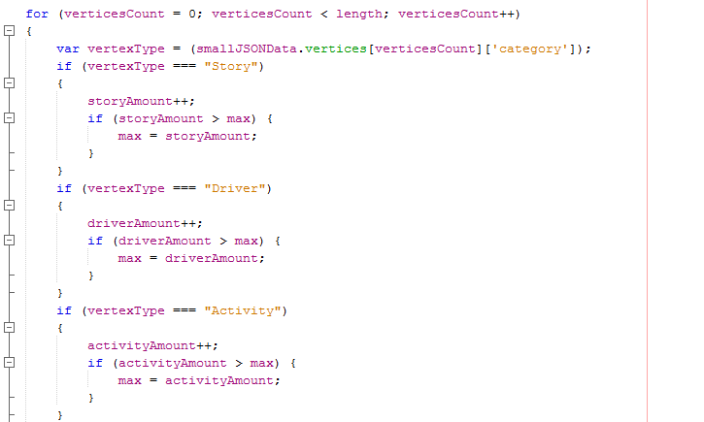

Figure 5.6: Code that determines how much of each node type is present

The reason we do this is to allow us to determine how large our paper needs to be. We use the most the most populous node type to determine the max width of our paper. We want each node to have sufficient space to potentially display knowledge and not appear cluttered.

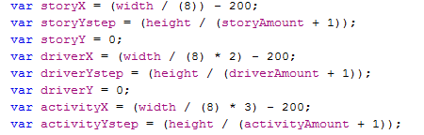

Figure 5.7: Assign each its initial position

X and Y coordinates are assigned based on the width and height of the paper. We determine a step i.e. the vertical distance between each node type based on the number of that type of node and the overall height of the paper e.g. if there are 3 or one type of node and the paper height is 1000px then the node step will be 250. This means that each node will be placed with y-coordinate of 250,500 and 750 respectively. This means the nodes have the maximum space between each other possible.

#### Draw Node

For each category of node, we draw a custom JointJS shape. Each node type has the same underlying structure but with different attributes added upon creation. 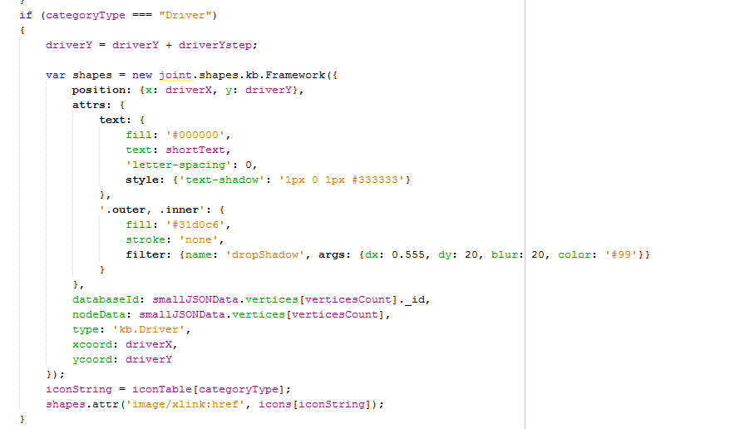

Figure 5.8: Draw DAPSIWR node

As you can see each time a node of a specific type is created the y-coordinate is incremented by the amount specified by the step value. The x coordinate remains the same as we want all nodes of the same type to appear in a vertical line. Each node has the shortened text value assigned to it that gives a brief description of the property of the node. The text was shortened to 15 characters as it helped declutter the graph.

As you can see as the node is created new attributes are added to it. These are the databaseId, nodeData, type, xcoord and the ycoord.

**databaseId –** This is the unique identifier that orientDB maintains to distinguish between nodes. This attribute is extremely important when we look to add edges to the graph as we require a method of determining what edges connect to what nodes. By adding the databaseId attribute here we can make it easily accessible later. We will talk more about this later.

**NodeData –** To this attribute, we assign all data that is received for each node to that node on its creation. By doing this we have access to all node data in a singular place that is accessible within the DOM. Because of this, it is very easy to access node data at a later point. Without adding this attribute, we would not have all node data easily accessible at a singular location and would make the building of dynamic lists very difficult.

**Type –** Type is used as an identifier to distinguish between the different type of nodes created e.g. knowledge, actors, drivers etc. This is helpful later when we want to examine nodes in a graph and we know we don’t need to consider knowledge nodes, by having the type attribute defined we can ignore these nodes in our computations and saving resources.

**X and Y coords –** As each node is drawn we record it x and y position. This is helpful later when we want to position knowledge and actor nodes relevant to each node. It again allows easy access to this data.

#### Node Image

Each Node category has its own specific image to represent it. Each image is mapped to a Base 64 string. From there it is mapped to a specific category name and called when necessary.

**Note** images mapped to Base 64 strings was used in the previous codebase and I repurposed it for my own use.

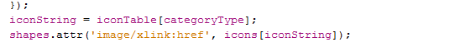

Figure 5.9: Node-specific images are loaded based on the category types

### Draw Node Edges

Next, we must draw all edges on the graph as they connect to the graph. Edges must be drawn after the nodes have been drawn as we need to obtain the canvasId to be able to pinpoint the location of the nodes on the canvas.

Like with nodes, we loop through all edges in the JSON data. In the JSON Data, there are 5 types of edges.

1. **‘S’** – this edges represents the link between a Story node and a Driver

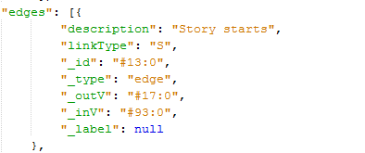

Figure 5.10: Example of JSON data for edge type ‘S’

It is relatively straightforward to draw all we need is the canvasId of both the target and the source node.

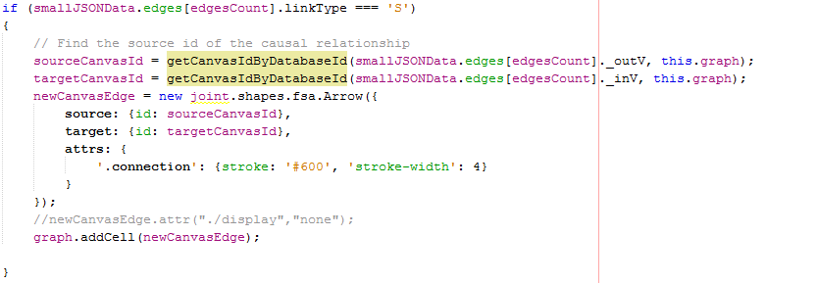

Figure 5.11: Code to draw canvas Edge

If the “linkType === ‘S’” we execute this piece of code. Since we know that all we require to draw this edge is canvasId of both the target and the source node.

#### Get Source/Target canvas ID



Figure 5.12: Get the source and target canvasId

To find this we pass two parameters to the getCanvasIdByDatabaseId () function. First, we pass the ‘_outV or ‘_inV’ databaseId property for this edge. ‘_outV’ refers to the databaseId from which the edge originates i.e. source and ‘_inV’ refers to the to the databaseId from which the edge terminates i.e. target. Next, we pass the graph in its current state i.e. with all nodes drawn. This object has a reference to every element drawn on the canvas. We do this because the graph has a reference to the canvasId property of the drawn element which is necessary to draw the link.

Next we step into the getCanvasIdByDatabaseId () function

**Note:** this function was present in the ResponSEAble codebase

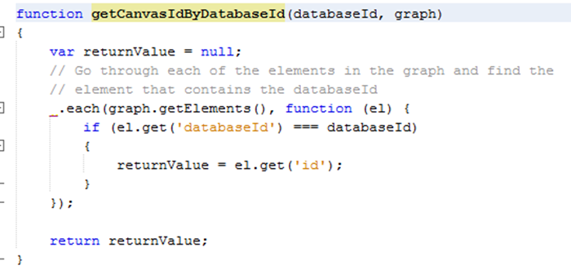

*Figure 5.13: getCanvasIdByDatabaseId () function*

In here we loop through each element previously added to the graph and check if the ‘databaseId’ property added when we created the node for the graph element equals the Id of the node from which our edge is originating from or terminating at. The ‘databaseId’ property is extremely important as it is our only way of verifying if the graph element is indeed the correct element from which our node originates/terminates and that we ensure we retrieve the correct canvasId. Without this property, we wouldn’t be able to correctly draw the edges between nodes. If the ‘databaseId’ from the graph element and our edge source or target match, then we retrieve the ‘id’(canvasId) of the element. The id property takes the following format id:"b2c11d70-c74a-44fd-8b3e-8437bcc3dfa2" This is a unique identifier for each element and is generated when each element is rendered. We return this value from our function and assign it to either the source or target variable. It is then used when drawing the new edge.

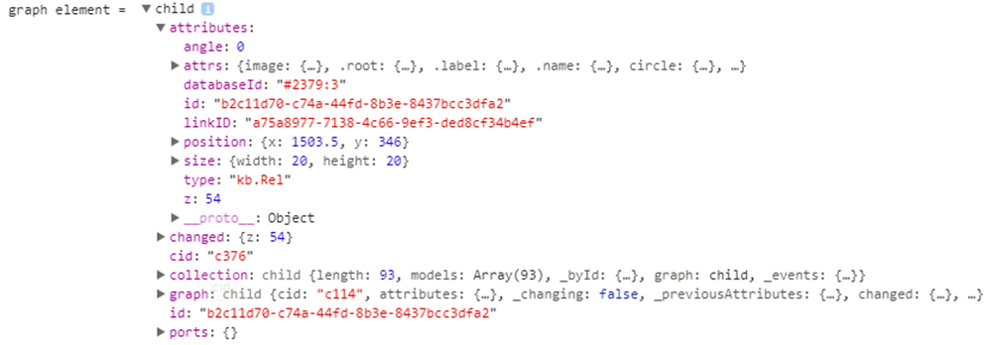

Figure 5.14: Easily access databaseId and id property in a graph element.

1. **& 3. ‘C1’ & ‘C2’ –** This represents the causal relationship between two nodes.

This is a slightly more complicated edge to draw as you must understand the structure of the ResponSEAble graph. When we want to connect two nodes we want to be able to display causal evidence that supports the relationship between these two nodes. When a user creates a causal edge two parts are created, C1 which is the link from the source node to a special node called the ‘LinkEvidence’ node and C2 which is the link from the LinkEvidence node to the target node. When we draw the edge, we want just one edge to be drawn with the LinkEvidence node appended on top of the link. The purpose of the LinkEvidence node is to attach knowledge to further support the relationship between two nodes. Thus, C1 and C2 edges always come in pairs and map to a common LinkEvidence node.

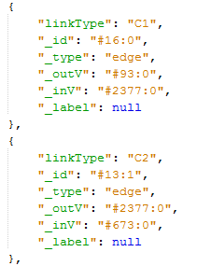

Figure 5.15: Example of an edge of linkType C1 & C2

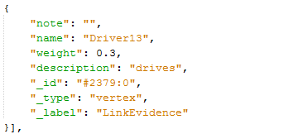

Figure 5.16: Example of a LinkEvidence node

Like every other edge, we draw we must find the canvasId of both the source and target nodes. However, with causal edges, we need to find the source node of edge C1 and the target node of edge C2 and then draw the LinkEvidence node in the middle of this new edge. If we encounter an edge of type ‘C1’ we find the canvasId for the source node using the same function as before. Next, we assign a variable called c1TargetNode to the databaseId of the target node for C1. Since we know C1 and C2 edges come in pairs and map to a common LinkEvidence node we can find the second half of the causal link by looping through the edges to find an edge of type ‘C2’ where the ‘_outV’ is equal to the 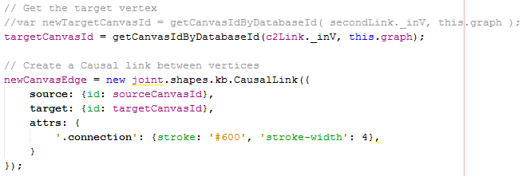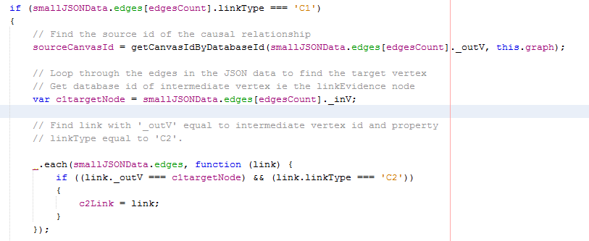‘_inV’ of the ‘C1’ edge.

Figure 5.17: Finding the target and source canvasId for a causal link

Then we do a check to ensure there’re no backward links i.e. links that don’t follow the DAPSIWR structure. We assume that only links originating from Response nodes will go backward. To do this we create an array that contains all response nodes.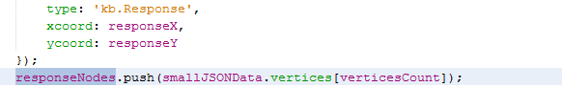

Figure 5.18: If the node is of type ‘Response’ we add it to an array containing all response nodes.

When we are drawing causal links we initially test to see if this link that goes backward. We do this before we draw the edge to save computation in the case it is a backward edge.

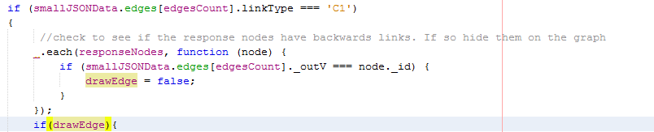

Figure 5.19: Test to ensure no backward edges are drawn.

Once we have verified that the edge can be drawn on the canvas we draw it. However, once we add it to the graph we must append the LinkEvidence on top of it. After we add it to the graph we call its setup function and pass the LinkEvidence _id to it. It is important that we pass this as we will require it later when we will attach knowledge to it.



Figure 5.20: Call setup function on newEdge and pass the databaseId to it.

When we create the new node to represent the LinkEvidence we must add the databaseId of the LinkEvidence node so that we can reference this node later when we look to attach knowledge to the causal edge.

**Note** this setup function was predefined, I merely added to it to better suit the needs of my project.

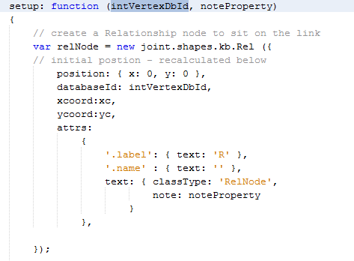

Figure 5.21: Add the databaseId property to the new node when setup is called.

The relNode is added to the graph. Next, we need to find the coordinates of the source and target nodes of the causal edge. We can access these attributes as they are present in the graph element. **Note** I modified this code from the existing codebase to better suit my needs.

We use the position of the target and source node to determine the midpoint and the most suitable place for the relNode to be drawn.

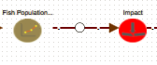

Figure 5.22: Example of a causal link with relNode appended

We can see here that the link between Fish Population and Impact is a causal link. The white node resting on the edge between these two edges represents the relNode and this is the point at which we will append Knowledge that supports the relationship between these two nodes.



Figure 5.23: Graph as it appears on initial page load

### Draw Knowledge Nodes & Edges

Here is the typical JSON data format for a Knowledge node.

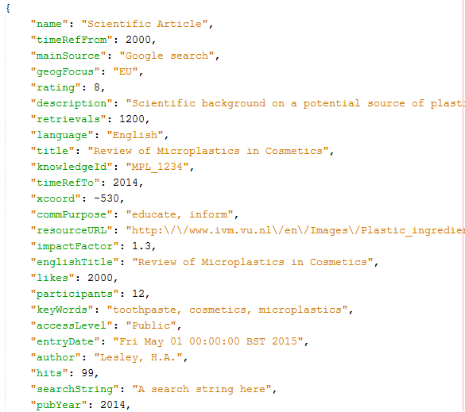

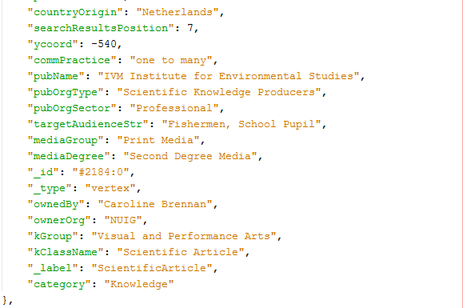

Figure 5.24: Typical JSON data format for a Knowledge node.

#### Determine how many Knowledge nodes are attached to each node

Knowledge nodes need to be drawn after all DAPSIWR nodes have been drawn so that we can access their canvas position and id.

We first need to determine how many knowledge nodes are connected to a single node. We do this by looping through all nodes in the JSON data and then looping through every edge in the JSON Data. If we find a link of type ‘K’(knowledge) whose source is the current node (i.e. a relNode or a DAPSIWR node) we step into another loop that again goes through every knowledge node in the JSON data and determines if the id of the of the Knowledge node is equal to the target of the knowledge link. Essentially we first determine if a knowledge link originates from the current node and it that is true we then find the knowledge node at which that terminates. Because of this, we can determine all the knowledge nodes that are attached to a single node. As we find the attached knowledge nodes we add them to an array called knowledgePerNode. Once all edges for a single node have been examined we send the knowledgePerNode array to a function that will sort and then draw all the knowledge nodes.

This is a very computationally expensive process to run as we need to examine every edge at every node. In large graphs, this could have a detrimental impact on performance. For this reason, we determine what actor nodes are connected to each node in this loop also. We will talk more about that later.

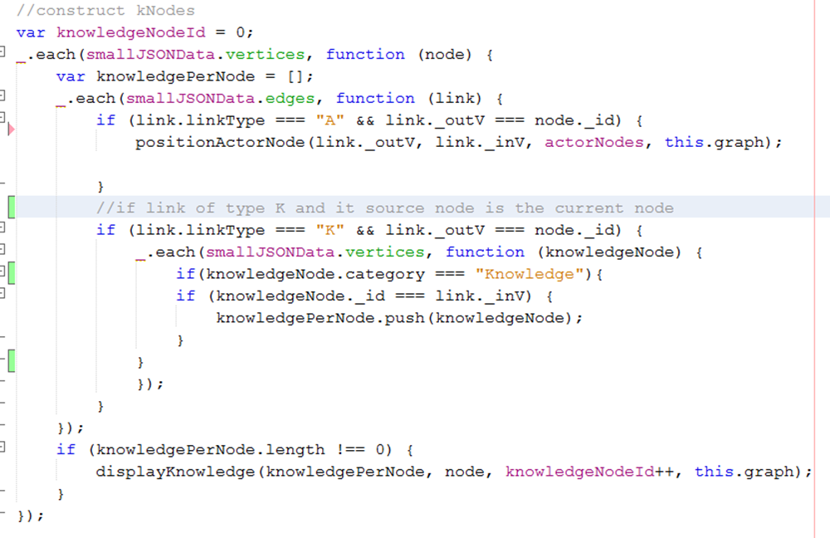

Figure 5.25: Code to determine how many knowledge nodes are connected to each node.

You can see before we test to ensure that the knowledgePerNode array is not empty before we send this to displayKnowledge. We also send extra parameters to the function.

**knowledgePerNode** - array containing the knowledge attached to single node

**node** – parent node upon which the knowledge will be appended around.

**knowledgeNodeId** – due to the fact that multiple knowledge nodes could have to be combined into one element we needed to create a new unique identifier for the node. By incrementing this value every time we call this function we can guarantee the uniqueness of the id. We further add another digit later on to ensure this.

**this.graph** – We pass this so we can have an up to date copy of the graph at the time of drawing. We will need this to access the canvasId and position of the source and target nodes.

To help improve performance we wait until the initial graph has loaded and then run the code necessary to draw the knowledge nodes in the background. Since the knowledge nodes are initially invisible on the page load the user won’t notice them missing.

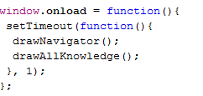

Figure 5.26: Draw all knowledge nodes in the background when the initial page has loaded

#### Determine how much of each knowledge node type is present

Once we pass this data to the displayKnowledge function we have to further separate the data into the 8 different kGroups of Knowledge as previosuly explained.

Regardless of the knowledge node type the method for drawing them follows the same procedure. In the displayKnowledge function, we separate these knowledge types and how many of each type are present. For instance, there might be 3 articles belonging to KGroup ‘Visual and Performance Arts’ This means we have to combine these 3 articles of Knowledge and represent them with a single node. We also do this to determine how many how many different types of knowledge is present.

To do this we create an empty array for each knowledge type and then loop through the knowledgeNodes data.

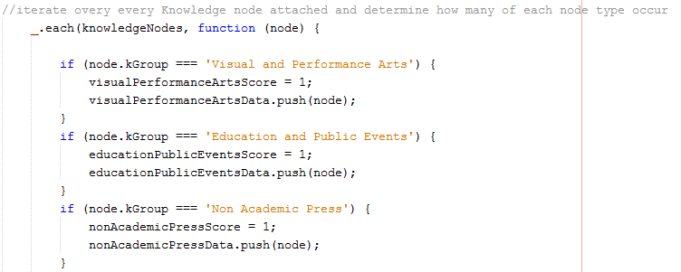

Figure 5.27: Loop through the knowledge node data and sort the data depending on its KGroup

The purpose of the visualPerformanceArtsScore = 1; is to keep track of whether this knowledge type is present. This is so we know how many knowledge types are present once we’ve sorted all the knowledgeNodes and can evenly space the knowledge nodes in orbit around their parent node.

#### Determine position of Knowledge node around parent

To determine the position of the Knowledge node we must first determine the position of the source node. We do this by extracting the data belonging to the graph element whos databaseId matches the id of the source node.

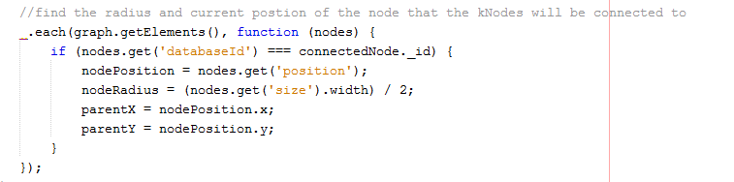

Figure 5.28: Find the node position and radius of the source node

Node radius is an important attribute because it can vary in size depending on whether it is a normal node or a relNode we are appending the knowledge to. Here we define variables necessary to find the orbit positions for knowledge nodes. We also find the number of unique knowledge nodes present by adding up all the score values.

Next, we test each individual array to check if it's not empty. The first step in verifying it's not empty is to find the coordinates for that knowledge node.

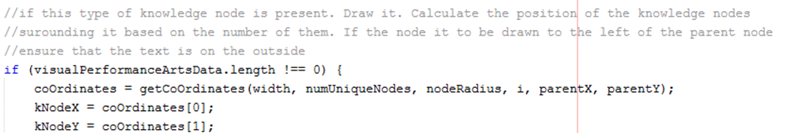

Figure 5.30: Function call to get coordinates for each knowledge node

The parameters we pass to this function are as follows

**Width -** width of the parent node. Important as the wider the node the greater the offset position will need to be.

**numUniqueNodes –** Count of the number of unique nodes. Determines the number of Knowledge nodes to be drawn. In Figure 5.30 below the node on the left has 4 unique nodes and the node one the right has 8.

**i –** Keeps track of the number of knowledge nodes drawn. i.e. is this the first or last knowledge node to be drawn. The value of ‘i’ is updated as we leave the if statement.

**parentX –** X coordinate of the parent node

**parentY –** Y coordinate of the parent node.

In the getCoOrdinates function we determine the locations at which to place each Knowledge node in such a way that they are placed equidistant from each other around their parent node regardless of the number of nodes.

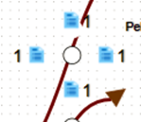 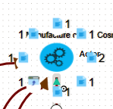

Figure 5.31: Knowledge is place at equidistant locations around its parent

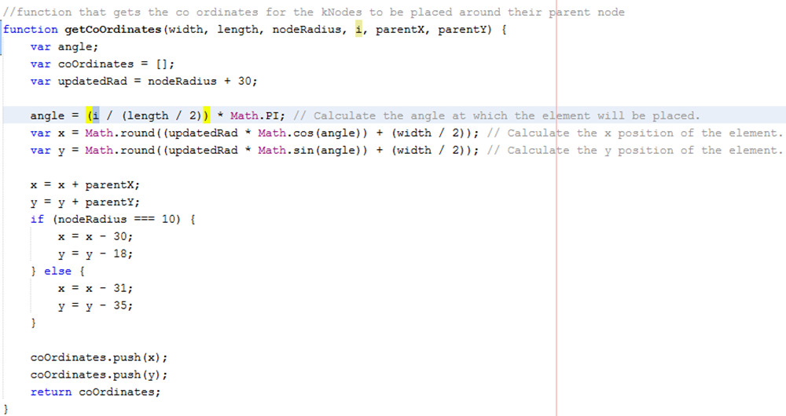

Figure 5.32: Method to find knowledge node position based on parent size and position

We then add the x and y coordinates to an array that is then sent back to the displayKnowledge function.

#### Draw Knowledge Node

Now that we have the coordinates at which our knowledge node will be drawn we can create and our knowledge node and add it to the graph.

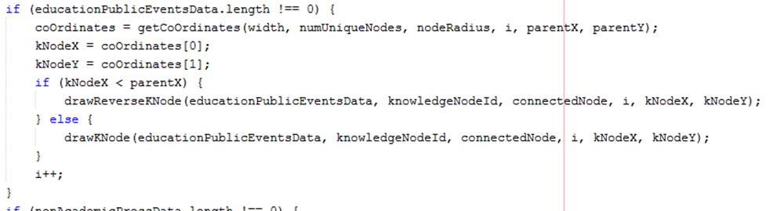

Figure 5.33: Code that calls the draw knowledge node function

You can see here that we do a quick check to test if the x coordinate of our knowledge node is less than that of the parent node. If it is less (i.e. meaning it is drawn on the left-hand side of the parent node) we call the drawReverseKNode function. The only difference here is that we want the number representing the number of articles present in the graph element to be drawn on the left-hand side of the knowledge element. See in Figure 5.33 below how knowledge nodes on the left of the parent node have the text to their left. This creates a more visually appealing look.

We pass several parameters to the drawKNode/drawReverseKNode function.

**educationPublicEventsData –** Array that contains all knowledge of a specific type. This could range from one knowledge article to many. We want this knowledge to be contained in the background of our knowledge for easy access.

**knowledgeNodeId –** this is the value passed from back when we added all knowledge for a single node to one array. This makes up one half of our unique id.

**connectedNode –** The node about which the knowledge will be orbiting or linked. We need access to its databaseId when we will be drawing the edge between the two.

**i -** This is the number of knowledge nodes that have been drawn around a single node e.g. 3 out of 4. This makes up the second half of our unique id.

Now that we have passed these parameters to the drawKNode function we can draw the new knowledge node.

This node is drawn the same as any other. We provide the x and y coordinate and define several attributes specific to this node.

We set the value for text to be the length of the data array. This means that if there are 2 articles of knowledge present in the array then the user will be visually informed of the number of articles present.

**type –** Same as before this differentiates this node from other by giving it a specific type of ‘kb. Knowledge’.

**supportingKnowledge -** this contains the array of all knowledge behind the node. This array could consist of one knowledge article or many.

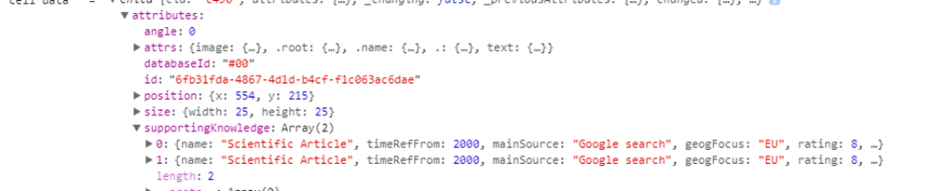

Figure 5.35: Example of supportingKnowledge appended to knowledge node.

**databaseId –** like every other type of node this is a unique identifier. In the image, above we can see that the database id is maintained as #00.

**kNodeY & kNodeY –** The x and y coordinates for our knowledge nodes.

We also originally set this node to display status of none. Meaning the user can’t see the knowledge node unless they wish to. This helps declutter the graph on original viewing. We then add the knowledge node to the graph.

Next, we look at the element which we use to render the knowledge node, its design and layout are very like that used for the rest of the nodes. The only difference is how we display the text. i.e. the number of articles present behind a node.

**Note**: This code was taken from the original codebase and modified for my use.

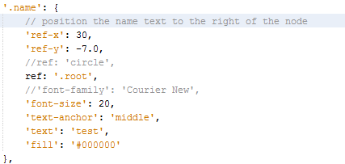

Figure 5.36: Position the text (number) to the right of the kNode.

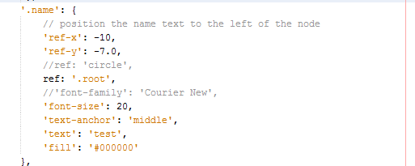

Figure 5.37: Position the text(number) to the left of the kNode.

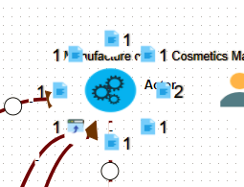

Figure 5.38: Example of how knowledge is drawn around its parent node.

### Draw Knowledge Edge

Once we have the Knowledge node drawn and added to the graph we draw the knowledge Edge connecting the knowledge node to the parent node.

Drawing the knowledge edge is straightforward. We simply create our own edge whenever a new knowledge node is created. Since the new node doesn’t map to any JSON data we don’t need to loop through the JSON edges data and draw all edges of type ‘k’. Like with every other edge we pass in the source node id and graph data to the getCanvasIdByDatabaseId () to find the canvasId for the source and then similarly find the canvasId for the target.

We then set the display status of the knowledge edge to ‘none’. This hides it from the viewer.

Although the knowledge edge between a knowledge node and a parent is never shown it is still necessary to draw it and preserve it on the graph as we will use it later to redisplay the knowledge nodes when the user wishes to see them. It is vital for keeping track of what nodes are connected to other nodes. We will talk more about this later.

### Draw Knowledge Nodes (alternate method)

Another method considered to represent knowledge for each node was to use a chart.js pie chart to display the knowledge data. Like the method we ended up using, we determined how many knowledge nodes were linked to a single node and then further sorted the knowledge data by separating the data into its 8 types(kGroup). We combined the knowledge rating for each knowledge type and used this determine what percentage of the pie chart that knowledge type should represent.

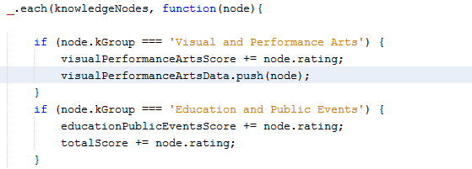

Figure 5.39: Determining the combined knowledge score for each Knowledge type

#### Draw Chart.js pie chart to represent Knowledge data

Next, we drew the pie chart to represent the knowledge data.

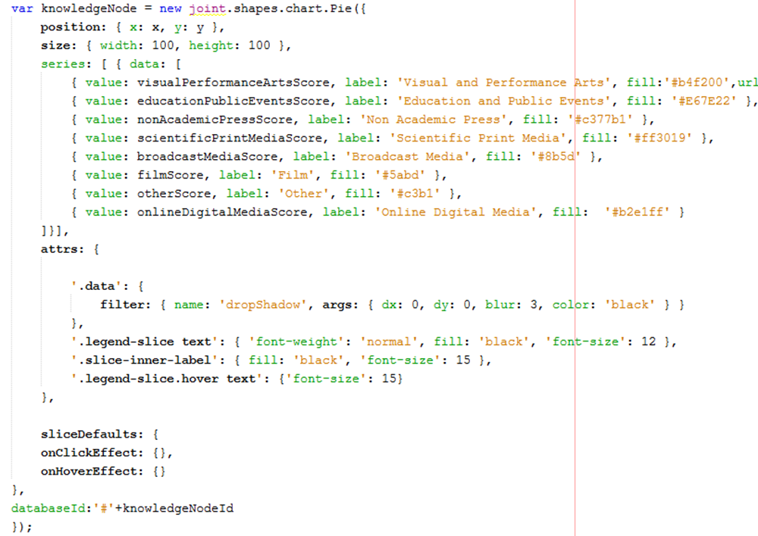

Figure 5.40: Draw a pie chart to represent knowledge node

Since there was only one node to represent all knowledge data we didn’t need to find the orbit positions around the parent node we simply offset the coordinates for the new node in comparison to the parent.

We created a series value for the 8 possible types of knowledge data and the value assigned to them was equal to the combined rating for each knowledge data type. 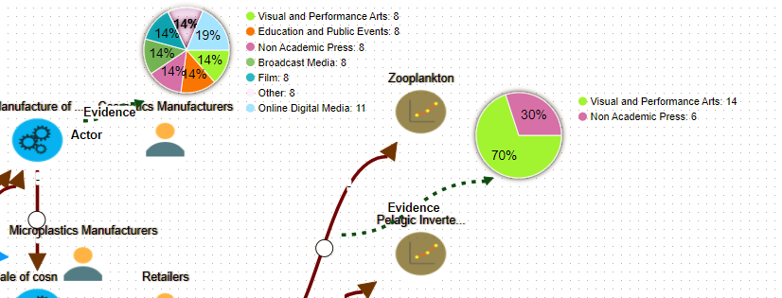

Figure 5.41: Example of how pie chart looked for displaying knowledge data

### Draw Actor Nodes

Here is the typical JSON data format for Actor nodes.

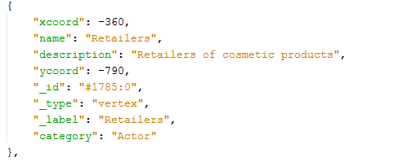

Figure 5.42: JSON data for Actor node

#### Create an array that contains all actor nodes in the JSON data

When we are looping through the JSON data vertices and drawing all the DAPSIWR nodes we add all actor nodes to an array for easy access later. It is easier to add all actor nodes when we are completing this loop as it saves on complexity by performing multiple functions in the one loop.

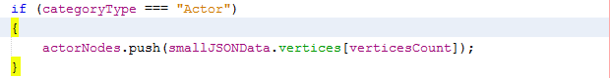

Figure 5.43: Add all actor nodes present in JSON data to a single array.

#### Determine if a node has a connected Actor node

Using the same code and loops that we used to determine the if a node had knowledge appended to it we loop through all nodes in the JSON data and at every node we examine all edges. If an edge is of type ‘A’ (i.e. Actor) and its node id is equal to the id of the current node, then we know that node has an actor connected to it. Like with knowledge nodes we wait until the initial page has loaded before we execute this code as it can add several seconds to the initial page load time.



Figure 5.44: Code that determines if a node has an Actor node connected to it.

We then call the positionActorNode () function and pass it the following parameters.

**link._outV** – The databaseId of the source node.

**link._inV –** the databaseId of the target node.

**actorNodes –** an array that contains all actor nodes that are present in the JSON data.

**this.graph** – contains an up to date copy of all elements drawn on the graph.

From here we call the positionActorNode function. Like displayKnowledge () we find the position of the parent node. However, instead of placing the Actor node in orbit around the parent node we just offset its x coordinate by 150.

Next, we loop through the ActorNodes array that we passed in and compare the databaseId of the targetNode and the ids of the ActorNodes in the array. If we have a match, then we know this which node the actorNode is connected to.

As we’ve done when we created every other type of node we added some custom properties to the node to allow for easy access to this data later when we want to view node data.

These are **type, DatabaseId,** and **nodeData.**

The node image is added using the methods previously described.

Like with the knowledge node the Actor node is originally set with display status of ‘none’ so that it is invisible to the user upon initial page load. This is to help declutter the graph and try to make it more readable.

#### Draw Actor Edge

Once we have drawn the Actor node we draw the Actor edge. This is very straightforward and simply requires us to find the canvasId of both the target and the source node. Like the Knowledge edge, the Actor edge is initially set to display status of ‘none’.

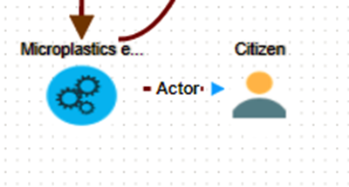

Figure 5.45: Example of Actor node connected to parent

### Show connected Knowledge & Actor nodes when the user clicks a node

When a user selects a node on the graph we want them to be able to toggle the display status of all connected knowledge and actor nodes.

#### Determine what edges and nodes are connected to a single node

Initially when the graph is loaded the user sees only the basic graph with no knowledge or actor nodes display. When the user selects, a specific node be it either a DAPSIWR node or a relNode the connected Knowledge and Actor nodes should be displayed to the user for that node only.

We first need to register when a user has clicked a node element on the canvas.

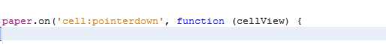

Figure 5.46: Detects when a user clicks on a node(cell) on the paper

This method returns to us the cellView as seen on the paper. This contains all data the data that we appended to this node when it was drawn. We can see that it holds a reference to its databaseId, nodeData, xcoord, ycoord which are all property’s we added upon creation of the node.

Now we need to find what nodes and edges are connected to a specific node if we want to find all connected knowledge and Actor nodes. To do this we first need to find the cell on the graph. We do this by looping through all cells in the graph and comparing their canvasId with the canvasId of the node we selected using cellView.

Figure 5.48: Loop through all cells in the graph

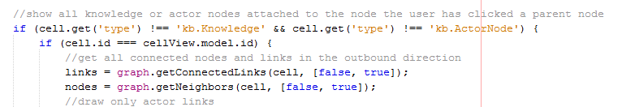

Figure 5.49: Compare cell and cellView canvasId to find the connected edges and nodes

Since we know the user won’t be clicking Knowledge of Actor nodes when displaying connected nodes, we don’t need to consider these in our comparisons and can save computation time. The reason we need to find the graph element is because JointJS has built-in methods for finding the connected Nodes and connected Edges for a node and we require the graph cell to use it. We call two functions to find the connected edges and nodes.

**graph.getConnectedLinks() –** Function that retrieves all edges that are connected to a single node.

**graph.getNeighbors() –** Function that retrieves all neighbouring nodes. (i.e. only one edge away)

We pass these functions two parameters.

**cell -** The node for which we want to find the connected edges and nodes.

**[false, true] -** This maps to the following [inbound, outbound]. By setting the second flag to true we retrieve only outbound edges and nodes. This helps reduce complexity.

The graph.getNeighbors() function is the reason we still must draw the knowledge edge even though the user never sees it. For this function to work there must be a link between nodes that can be traced on the graph.

#### Show Knowledge and Actor Nodes

Once we have an array of all connected nodes and edges we can loop over each array.

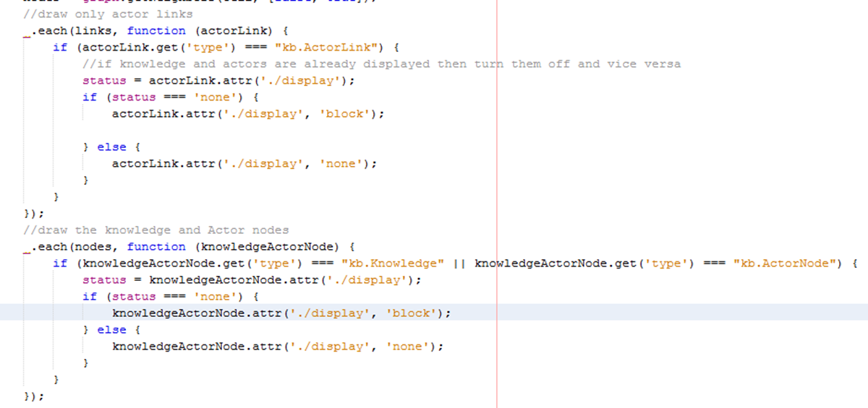

Figure 5.50: Loop over each array and draw the connected nodes and edges

When we are looping over the edges array we only want to show edges of type ActorLink. This is where the type property defined on the creation of edges and nodes comes in useful. We can differentiate between edges using this attribute. We first check the current display status of the ActorLink and if it is currently set to ‘none’ (the initial value) then we set it to ‘block’ (i.e. visible). Similarly, if the display status is ‘block’ then we set it back to ‘none’. This allows the user to toggle the display status of Actor links around a node.

Similarly, when updating the display status of Knowledge and Actor nodes we loop through the nodes array obtained by the getNeighbors () function. We again use the ‘type’ property defined on node creation to differentiate between node types. In this case, we want to update the display status of both Actor and Knowledge nodes. The procedure is the same as for edges as we allow the user to toggle the display status.

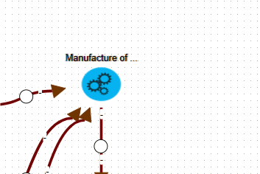

Figure 5.51: Before click with no Knowledge or Actors displayed

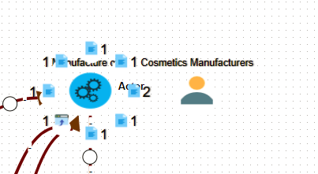

Figure 5.52: After click event with both Actor and Knowledge nodes visible.

### Draw all Knowledge Nodes on Button Toggle

When a user wishes to view either all Actor or Knowledge nodes on a graph they can click on the two toggle buttons on the navbar in the MainViewer.html file.

When the user clicks this button, it activates the drawAllKnowledgeNodes function and passes it the status of the toggle button. (i.e. clicked or not).

In the drawAllKnowledgeNodes function if the status of the ‘aria-pressed’ the attribute is false (status will be false on initial click. i.e. when the user wants to display knowledge) we cycle through all nodes currently on the graph and if the ‘type’ is ‘kb.Knowledge’ then we set the display status for that knowledge node to ‘block’. This is again another example of the type attribute defined on node creation coming in handy. Similarly, if the user toggles the button (i.e. wants to turn the knowledge off we set the display status of all knowledge node to ‘none’).

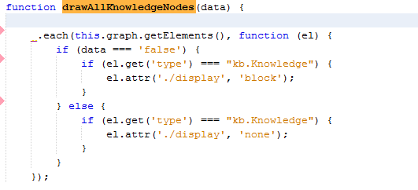

Figure 5.53: Display/Hide all Knowledge nodes in the graph on button toggle

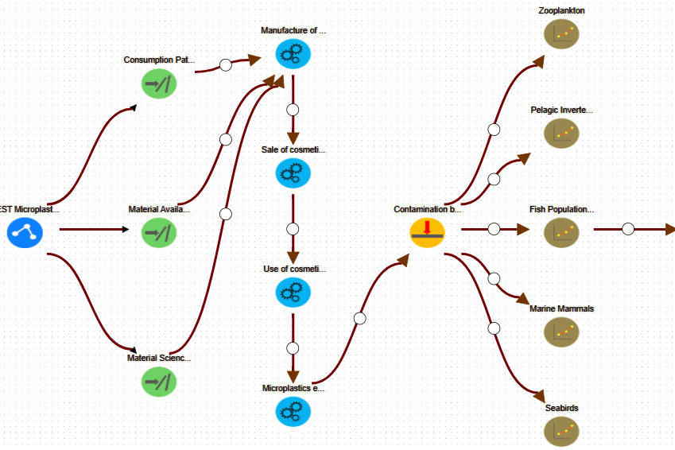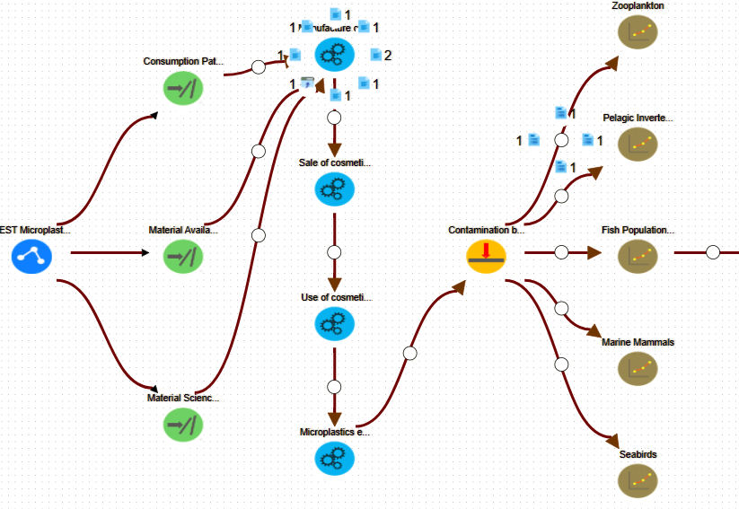

Figure 5.54: Graph before and after all Knowledge was activated.

## Draw all Actor Nodes and Edges on Button Toggle

This is like the action performed when the user wishes to show all Actor nodes on a graph. The only difference is we must use the getConnectedLinks function to find the connected Actor Links and toggle their display status.

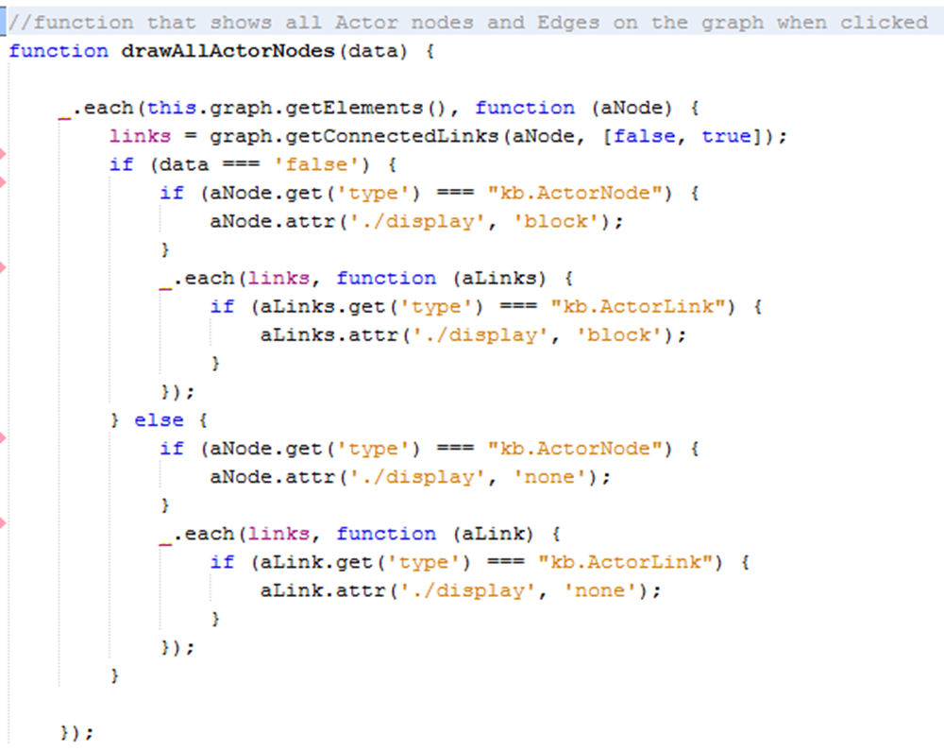

Figure 5.55: Toggle display status for Actor nodes and edge.

You can see we cycle through all nodes in the graph and get the connected links for each node. If a node is of ‘type’ ‘kb.ActorNode’ then we toggle its display status, similarly for edges if they are of ‘type’ ‘kb.ActorLink’ we also toggle their display status.

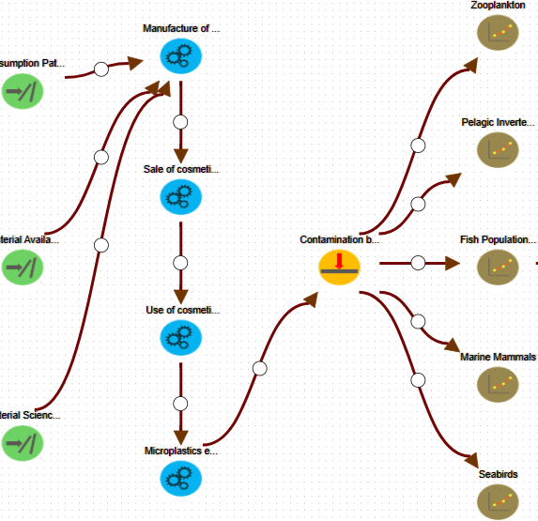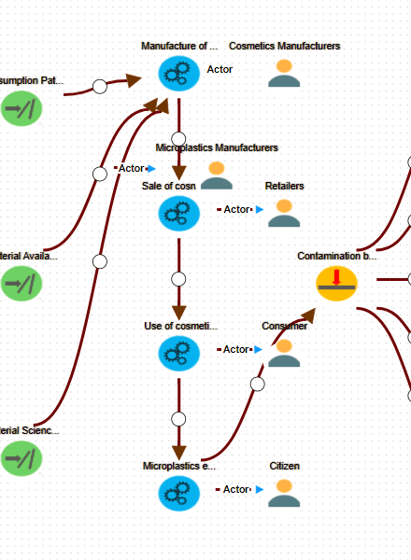

Figure 5.56: Graph before and after Actor nodes and links were activated

### Display Data Relevant to each node

When a user selects a single node, we want to present to them all the data that is present to support this node. This data is broken down into 3 categories.

**Node Data** – This is the data that belongs to the actual node the user select. i.e. node name, description, category etc.

**Knowledge Data** – If the user has selected a node that has knowledge connected to it then we want to display this to the user. E.g. one or more of the 8 categories of knowledge are supporting the node.

**Actor Data –** Similarly if the user has selected a node that has Actors connected to it then we also want to give the user an opportunity to view this data.

All data is dynamically appended to bootstrap list-group dropdowns that are populated as the data is read. We initially create bootstrap buttons in our MainViewer.html file and append the parent ‘list-group’ for each data type. The buttons are initially set with a display status of ‘none’ and only become visible to the user if there is data present to populate them.

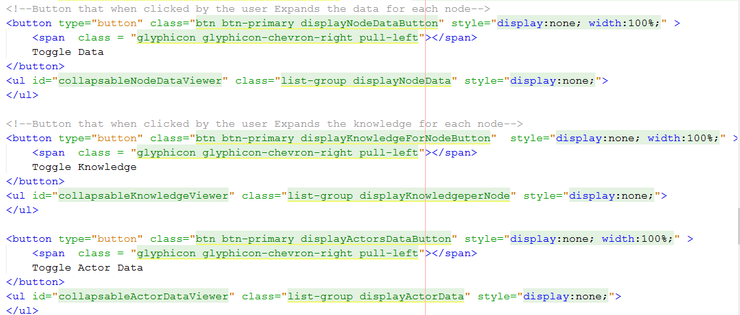

Figure 5.57: Bootstrap buttons that contain parent ‘list-group’

#### Retrieve Node Data

When the user selects a node, we want to display all data relevant to this node. When a user selects a node we initially hide all buttons and empty all ‘list-groups’. This is to remove information relevant to a previous node and to also hide data categories that might not be relevant to the current node. E.g. the user may have previously selected a node that has knowledge data and the current node does not.

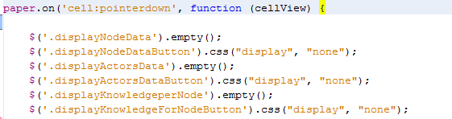

Figure 5.58: Use JQuery to hide buttons and empty divs

Once we have reset our list-groups for a new data set we again use the getNeighbors () function to get all connected nodes.

Once we have an array of connected nodes we cycle through them and if any knowledge nodes are attached we extract the supportingKnowledge behind each knowledge type. To do this we access the ‘supportingKnowledge’ property defined when we originally created the knowledge node which contains all the JSON data for each category type.

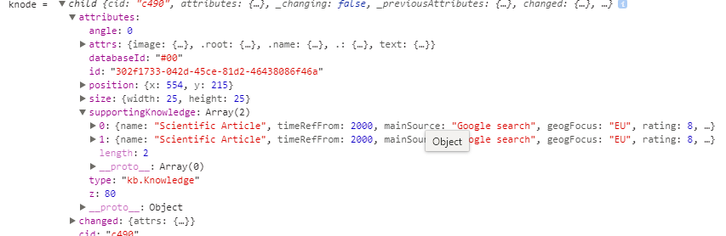

Figure 5.59: Supporting knowledge is maintained in each knowledge node and easy to access

For each Knowledge node connected to the node the user selected we add the supporting knowledge to an array that we can then pass to our function that will populate the drop-down lists. We also add data relevant to connected Actor nodes to separate array. We similarly access the nodeData property defined on the Actor nodes creation. This contains all JSON data relevant to each actor node.

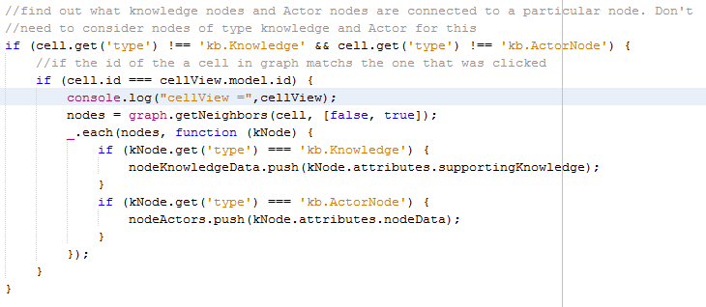

Figure 5.60: Find all connected Knowledge and Actor nodes and add them to separate arrays

We also access the nodeData and nodeType. Again, these are properties that were defined and populated on node creation. Because these properties are accessible from the cellView we don’t need to find the graph cell to access them.



Figure 5.61: Access nodeData and nodeType

Once we have constructed our arrays with all connected data categories. We do a test to check if each array has data in it and if so we forward control to the appropriate function to populate the lists.

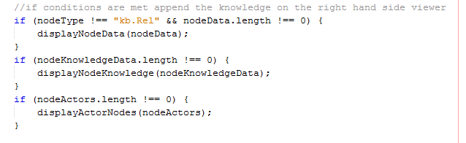

Figure 5.62: Check to ensure array isn’t empty and call appropriate functions

Due to relNodes or LinkEvidence nodes not having substantial data to support them we don’t display node data for them.

#### Display Node Data

We pass only nodeData to this function. We first set the visibility status of the toggle button to visible using jQuery to access the correct button and change its property.

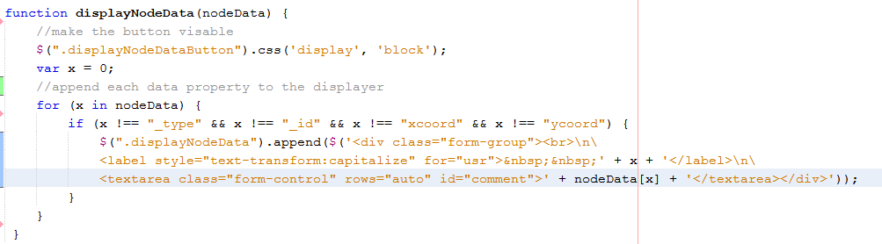

Figure 5.63: Use JQuery to change display status and dynamically append JSON data

We filter out data properties _type, _id, xcoord and ycoord that won’t provide the user with any relevant information.

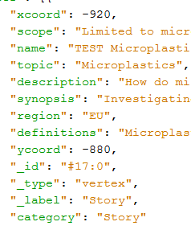

Figure 5.64: Example of how we access key-value pairs.

For JSON data of the above format “for (x in nodeData)” allows us to access each key-value pair that is present. For the first line above x would represent “xcoord” and nodeData[x] would represent -920.

This allows us to iterate over all key-value pairs and append each key-value pair to the list-group. This means the JSON data format could change in the future yet still display all attributes.

We use the value of ‘x’ as the label for our form group and use the CSS styling attribute ‘text-transform: capitalize’ to capitalize the first letter.

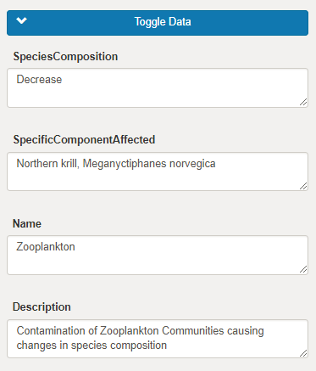

Figure 5.65: Node data displayed in the drop-down menu.

#### Display Knowledge Data

We only pass Knowledge Data to this function. This is slightly more complicated to append data to the dropdown list as we could have multiple arrays within the original array. Like with the displayNodeData we initially set the display status of the button responsible for containing this data to visible using JQuery to edit the CSS display property.

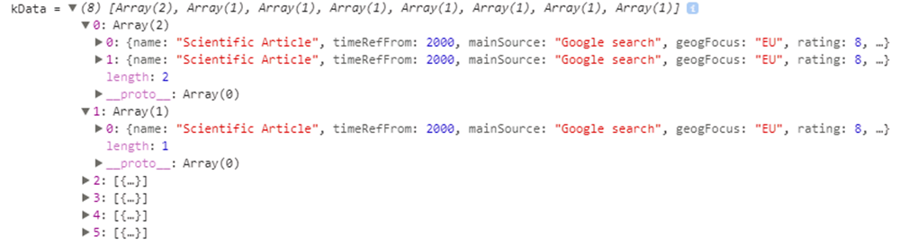

Figure 5.66: Format of the array as it arrives in DisplayKnowledgeData

We can see that the first value of the arrays contains multiple values. i.e. this knowledge type has more than one supporting article.

We first iterate over the outer array and use JQuery to append a new list group item for each category type present. We use the name of the knowledge kGroup (e.g. Scientific Article, Film, etc.) to distinguish between list groups. We also attach a badge that visually informs the user how many articles of this type are present at a glance.

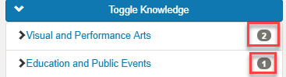

Figure 5.67: Informs the user of the knowledge category and the number of Articles present

Within this new list group item, we then append a list group of type collapse that will contain all the data for this knowledge type. We can reference this specific list group when appending the JSON data by the “knowledgeItemNumber+i+ “class name we assign it. The value of ‘i’ increases as each new list is created ensuring each list has a unique class name and contains the correct data.

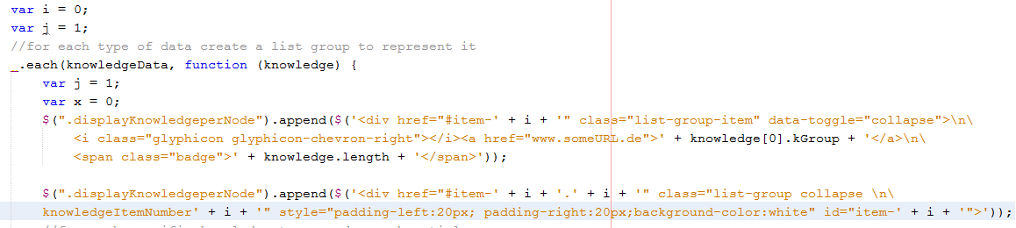

Figure 5.68: Dynamically creating collapsible list groups that can hold Knowledge Data

Once we have defined our list we then step into the inner array and iterate over it. We first append a badge that visually informs the user the current article they are viewing (e.g. article 1,2,3 etc.).

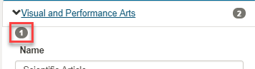

Figure 5.69: Inform user that they are viewing the first article

We then use JQuery to reference the “knowledgeItemNumber+i+ “list previously created. We can then use the same method used in DisplayNodeData to append the key-value pair JSON data dynamically.

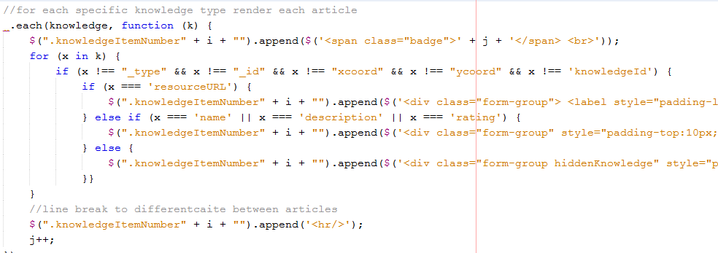

Figure 5.70: Iterate over the inner array and dynamically append JSON data

Like displayNodeData, we filter out some data properties as they don’t provide relevant information to the user. Except for the resourceURL property we append all key-value pairs into a text Area. With resourceURL we append a ‘href’ instead so that when the user clicks it they are brought to a new webpage that loads the knowledge article.

After each iteration of the inner array, we insert a line break to further distinguish between articles.

#### Display Actor Data

We send only Actor data to this function. Like with the other functions we first set the button display status to visible using JQuery. This follows a similar procedure as DisplayKnowledgeData as we could have many actors connected to a single node but is not as complicated as there won’t be any nested arrays like there was with DisplayKnowledgeData.

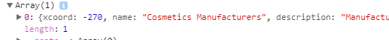

Figure 5.71: Format of data received by DisplayActorData function

The procedure to append Actor data is the same as in DisplayKnowledgeData. We iterate over each actor node and create a unique list-group to hold the Actor Data. We then use JQuery to access our unique list and append each key-value pair while filtering out irrelevant data.

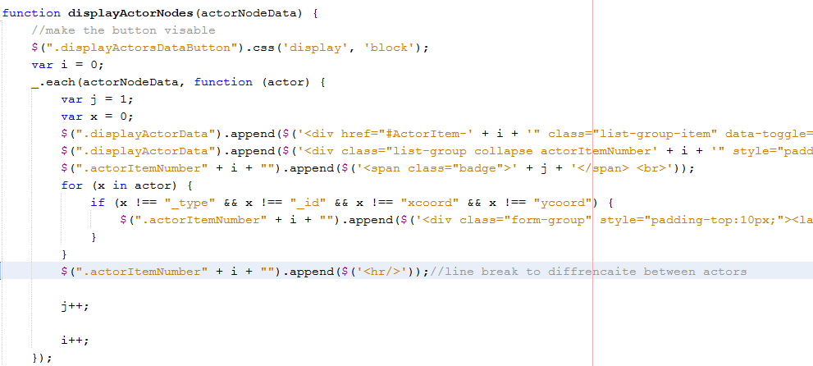

Figure 5.72: Append Actor data to list-group

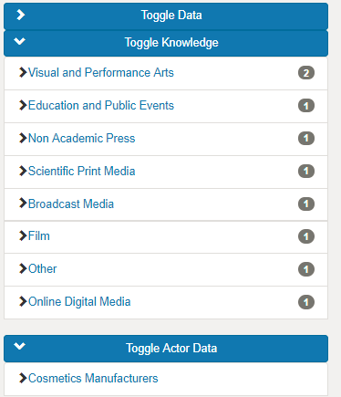

Figure 5.73: Node Data viewer after all data has been appended

## Detect User click on button and lists

We use JQuery to detect when a user clicks the buttons and lists that contain data relevant to the selected node.

#### Detect Button Click

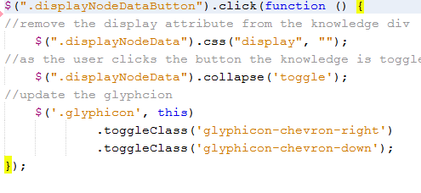

Figure 5.74: Detect Button click

Using JQuery we can detect when a user selects a specific button. When clicked, the following actions occur

* We remove all display attributes because if they are left in the cause flickering to occur as the user toggles the button.
* Toggle the button collapse.
* Change the glyphicon class to represent the current status.

We use the same method to detect all button clicks for displaying data relevant to a specific node.

#### Detect list-group clicks

When a user clicks on an element contained within the button class it is slightly more difficult to detect as we need to provide JQuery with a more specific path to the element due to it being dynamically created and the class name is not present in the HTML file.

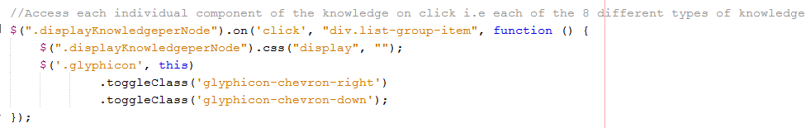

Figure 5.75: Detect user clicks on individual list-groups

Once we register this click event we perform the same actions as we did for the buttons in the previous step. This click event also toggles the list-group.

### Display Causal Summary

When the user activates the toggle button on the navbar they can then select two nodes on the graph and submit a query that will retrieve all causal knowledge that links these two nodes should be found displayed to the user so they can view the knowledge that supports the connection between nodes. The path for which the causal evidence will be retrieved is also highlighted.

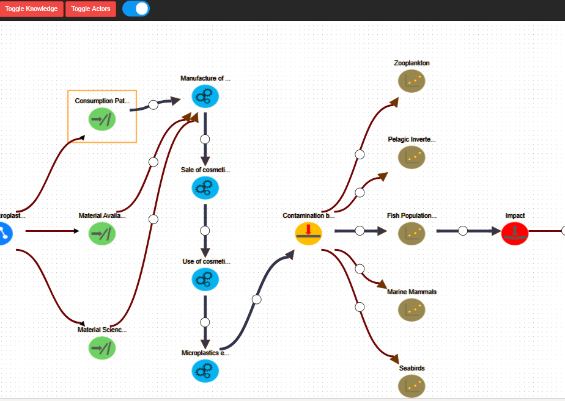

Figure 5.76: User has selected start and end node to retrieve causal evidence

To highlight this path, we use Dijkstra’s algorithm to find the shortest path between the two selected nodes. We then individually highlight every link on this path. This path will also match that returned from the backend as it also selects the shortest path.

#### Write Ajax call

We use an Ajax call to retrieve the causal Evidence between two nodes from the Database. All we need to provide is the databaseId of the start and end node

#### JSON Data returned by ajax call

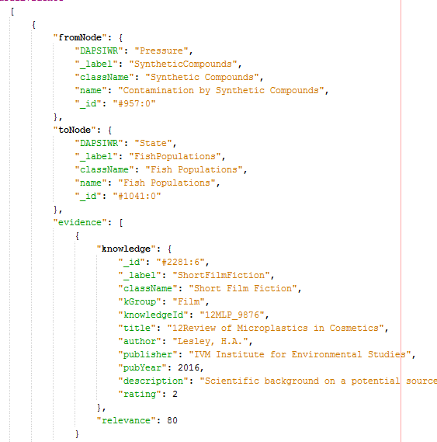

Figure 5.77: Format of JSON data returned for Causal Evidence

#### Extract and sort Evidence from JSON data

We first iterate through all evidence in the JSON data returned and add it all to one array. This is so that we have all returned evidence in one location.

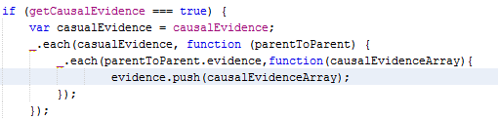

Figure 5.78: Extract all knowledge returned in JSON data

We then separate the evidence into separate arrays based on its knowledge category. This is very like the method used earlier when we separated the knowledge into different categories when we wanted to draw the knowledge nodes. The only difference is down to the JSON structure meaning we can’t reuse the same code.

Once we have separated the knowledge based on its category we check to see if the array it’s contained in is not empty and if so we add it to a single array which we then send to the displayCausalKnowledge function to display the causal data.

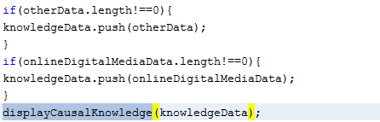

Figure 5.79: Add knowledge type to a single array and send the array to displayCausalKnowledge

#### Display Causal Knowledge

We first ensure any data displayed before the causal Summary was generated is removed from the viewer and all buttons are hidden.

We use nearly the same method to dynamically create and append the causal evidence to the list-groups as we used previously for when the user clicked on a node. The only difference is the structure of the JSON data meaning we can’t reuse the same code to perform this task for us.

We also set the status of the viewCausalSummaryButton to visible. This is responsible for loading the summary chart.

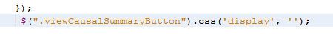

Figure 5.80: Set display status of viewCausalSummaryButton to visible

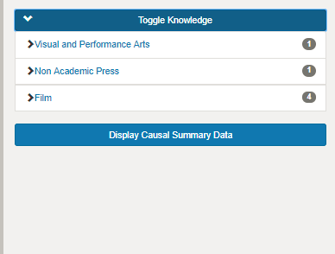

Figure 5.81: Causal Evidence is displayed in the viewer and separated by category

### Draw Summary Graph for Causal Data

We also want to present the user with an option to get a quick view of the causal data supporting the connection between nodes. For this purpose, we used a chart.js bar chart to display the number of articles present in the causal evidence.

#### Create Button and Modal

We first create a toggle button in our HTML file that the user will click when they want to display the causal summary. The display status is initially set to hidden as we only want this to appear when a causal evidence summary can be viewed.

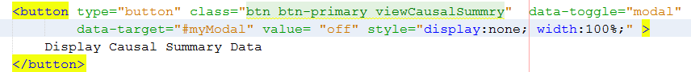

Figure 5.82: Bootstrap button that user clicks to view causal summary

When the user clicks the button, they trigger a model window to render.

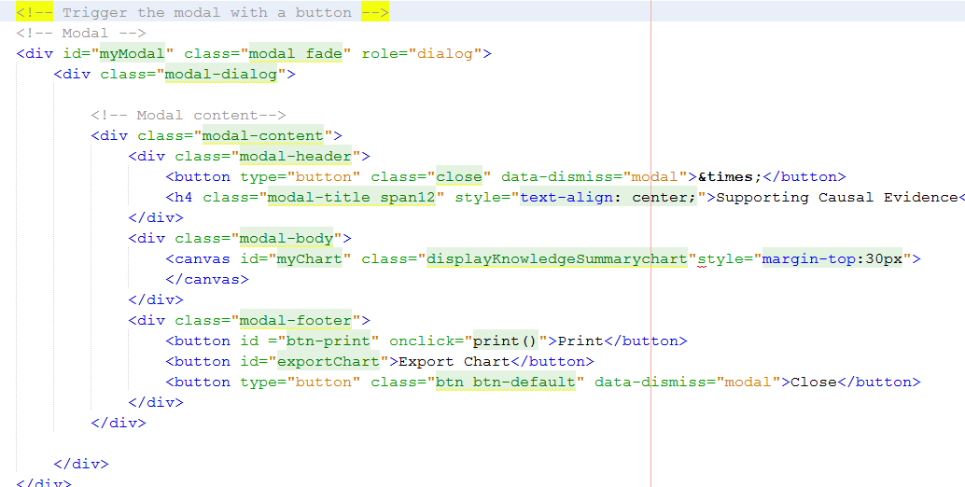

Figure 5.83: Render modal window that will display the graph

#### Draw Graph

At the same time when the user clicks the viewCausalSummary button, we use JQuery to detect the click, draw the chart and append it to the modal window that we just opened.

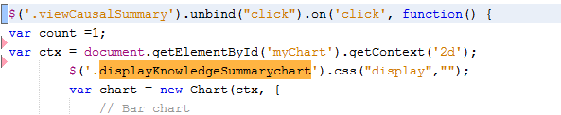

Figure 5.84: JQuery detects button click and appends bar Chart to the modal canvas

This method is still present in the displayCausalEvidence function so we have access to the causal evidence that has been sorted by category.

We now define our 8 different types of categories to be on our x-axis. We still it to be obvious to the user at a glance if knowledge of a certain category is not present.

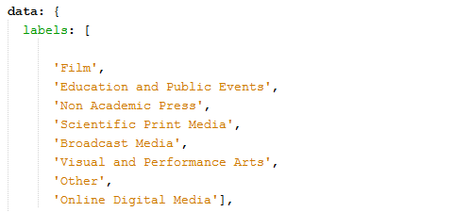

Figure 5.85: Define labels (x-axis values)

Now we add the length of each individual knowledge category to be the height of each bar chart. This visually tells the user at a glance what knowledge type and how many of each are present. If the user wants to drill down and examine the knowledge they can do that using the list-groups previously created. We also define a color for each bar.

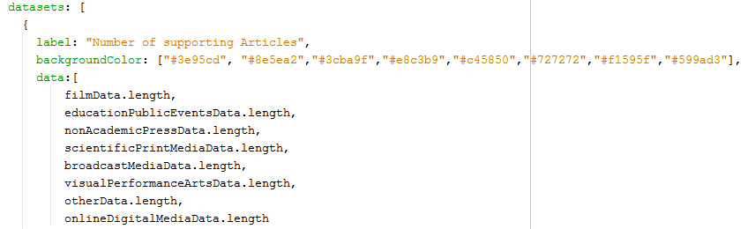

Figure 5.86: Set the height of each bar using the amount of each knowledge category present

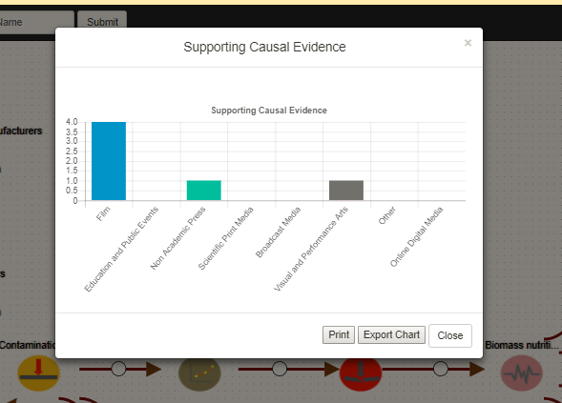

Figure 5.87: Causal Data Summary chart

### Allow the user to print the Summary Chart

The user can print the chart by clicking the print button present in the footer of the modal window. We create a HTML button that calls window.print when clicked.



Figure 5.88: Button to print chart contents on click

We then use the CSS @media print to only display the div that we specifically want to print which in this case is just myChart and the canvas. Everything else on the window is hidden from view. We then also ensure that the divs we want to print appear in a central position of the paper.

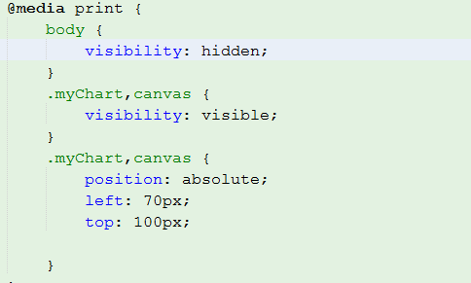

Figure 5.89: Hide all content except what we wish to print

This then brings them to a new window where they can decide where they wish to print the image. By allowing the user the option to print the image the can also easily save the image to their device in any format they wish.

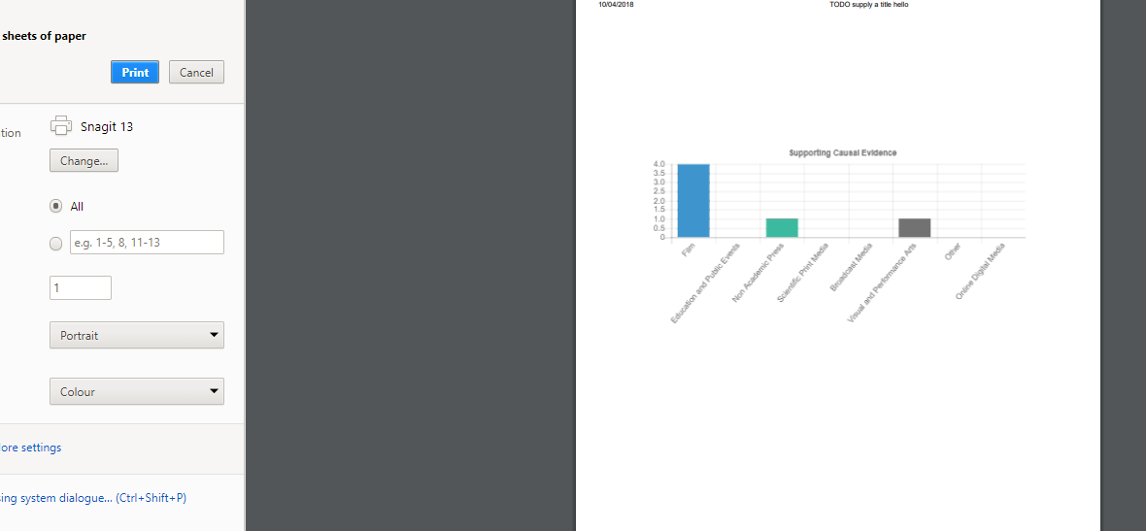

Figure 5.90: Print Preview

*Chapter 5*

# Conclusion

The result of this project is an interactive, intelligent user interface that allows a user to explore the knowledge in the graph database, both visually and using queries. The UI has a logical flow to its structure that makes it easy to read. Users can visually explore and examine specific stories. Users can select specific start and end nodes on the graph and retrieve the causal evidence that supports them being linked. Users can also view all data that is connected to a specific node.

All but one of the project’s main goals were achieved.

* Developed an intelligent user interface that the user can interact with and has a logical flow that makes the graph more readable.
* Designed a method of allowing the user to query specific sections of stories that allows supporting evidence to be returned. The user can interactively select the start and end points.
* Designed and implemented a method of visually displaying the evidence that is present in a specific link or the evidence returned from a query.
* Developed a method that will visually inform the user that a specific link or vertex has supporting evidence.
* Designed and implemented a method for displaying node-specific data.
* Developed a method for displaying Actor specific data.
* Developed a method for displaying to the user if a specific link or vertex has Actors connected to it.

The only goal I did not achieve was to create a weighting scheme that would be used to determine how much evidence a node or link had supporting it. The goal had been to use this weighting scheme to visually inform the user that a node or link has supporting causal evidence by using thicker causal links to represent edges with more supporting evidence. Similarly, for nodes, we would have used this weighting scheme to create some visual around nodes to display that they had more supporting evidence. Onew idea was to use concentric circles around a node to signify more evidence.

However, the user can easily activate all knowledge on the graph with a click of a button and are then visually informed of the knowledge that supports a particular node or link.

Overall I am satisfied with what I have achieved with this project. Hopefully what I have created can be of use going forward to the ResponSEAble web page and help improve its UI.

*Chapter 6*

# Future Work

There is a number of tasks that could be undertaken to further improve and expand upon the work completed in this project.

The main task that I would like to see completed would be to create some form of weighting scheme that represents the amount and quality of supporting evidence behind a link or node. This scheme could then be further used to create some visual on both nodes and edges that would inform the user of the strength of supporting knowledge.

Similarly, this weighting scheme could be used to rank evidence when it is displayed in the viewer on the right-hand side of the page. The user could sort the supporting evidence to have the most relevant and accurate knowledge displayed first. This would help filter out irrelevant supporting knowledge.

As it stands a specific node or link could have the most supporting articles in the graph but the user has no method of quickly judging the quality of the evidence. All this supporting evidence could possibly be irrelevant to the causal relationship but it could give the impression of a strong relationship.

*Chapter 7*

# References

[1] - <https://www.responseable.eu/>

[2] - <https://netbeans.org/>

[3] - <https://guides.github.com/activities/hello-world/>

[4] - <https://www.w3schools.com/html/default.asp>

[5] - <https://www.w3schools.com/js/default.asp>

[6] - <https://www.w3schools.com/css/default.asp>

[7] - <https://www.jointjs.com/>

[8] - <https://www.w3schools.com/html/html5_svg.asp>

[9] - <http://tobiasahlin.com/blog/introduction-to-chartjs/>

[10] - <https://www.w3schools.com/jquery/jquery_intro.asp>

[11] - <https://www.w3schools.com/bootstrap/default.asp>

[12] - <https://orientdb.com/>